8D分析改善报告
W/DP QA-Q5005-02

NO.20170626001
8D Analysis Improvement Report
产品型号 Product Model |  |  | O11F-L311-20.00MHz |  |  |  |  |  |  | 开始时间 Start Date |  |  |  |  |  | 20170602
来源 Source |  |  | G024 |  |  |  |  |  |  | 报告时间  Report Date |  |  |  |  |  | 20170626
组长Team Leader |  |  | 陈京武 Jim.chen |  |  |  | 组员 Members |  |  | 周文、罗胜贵、冯刚涛、王春明、李洪润、程国华，李自豪
问题描述 Problem description：
客户投诉&抱怨Customer complaint |  |  |  |  |  |  |  |  |  | 数量Qty |  |  | 哪里 here |  |  | 时间Date
Customer feedback the product of O11F-L311-20.00MHz was failure at 2426s by a spike in the TIE data during testing G.8262 Opt2 BW=68mHz at 70C const. The customer returns the failure samples and need to find the root cause. |  |  |  |  |  |  |  |  |  | 1 |  |  | G024 |  |  | 2017-06-26
不良原因分析Failure Analysis Result：
- 外观检查 Visual Inspection
#1 20160725140
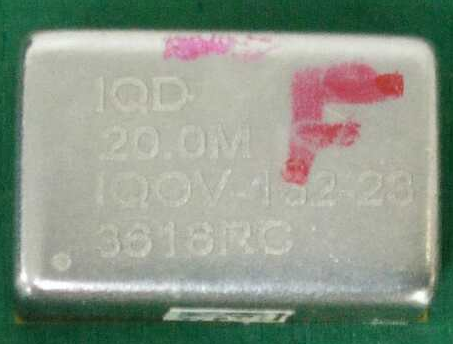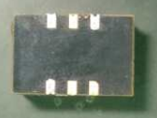

Visual inspection：No found any damage issue except red marking in the top surface.
The residual solder of the pin is proved that the product had been to be used.
- Electrical performance verification性能检测
Base on the analysis report from the customer, it reported the product had good performance for the normal electrical parameters. We test the product’s performance again to verify any abnormal can be found. The test result showed the performance meets the specification’s requirement, the test result as below:
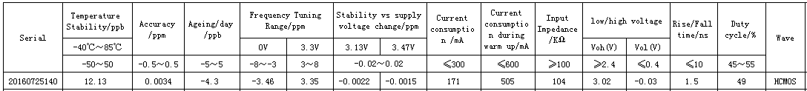
Check the outgoing final test data and find all of the electrical parameters can meet specification’s requirement, the outgoing data as below:
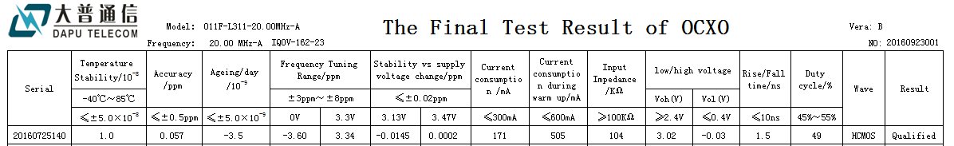

2.1 频率准确度测试 Nominal Frequency Test
The product has normal frequency output is 19.199995000MHz.
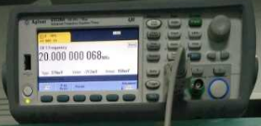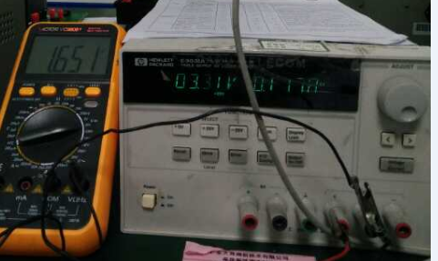
2.2 波形测试Waveform Test
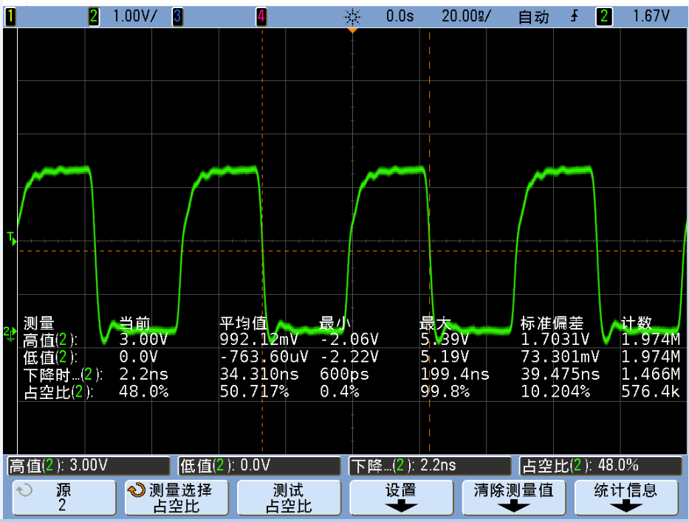

The Waveform was normal, The high level of output voltage is 3.3V, the low level of output voltage is 0V, the rise and fall time is 2.2ns,ducy cycle at 48.0%, the test result can meet specification’s requirement

2.3 相噪测试.Phase Noise Test
The phase noise test result as below table: No any abnormal was found in the 10Hz to 1MHz frequency scope during the phase noise test.

频率Freqyency | 测试结果Test data | specification | Result
10Hz | -107.2492dBc/Hz | ＜-90dBc/Hz | Pass
100Hz | -133.2547dBc/Hz | ＜-120dBc/Hz | Pass
1KHz | -147.0108dBc/Hz | ＜-145dBc/Hz | Pass
10KHz | -154.3811dBc/Hz | ＜-145dBc/Hz | Pass
100KHz | -155.7328dBc/Hz | ＜-145dBc/Hz | Pass
1MHz | -155.5145dBc/Hz | ＜-150dBc/Hz | Pass

The phase noise test waveform as below:
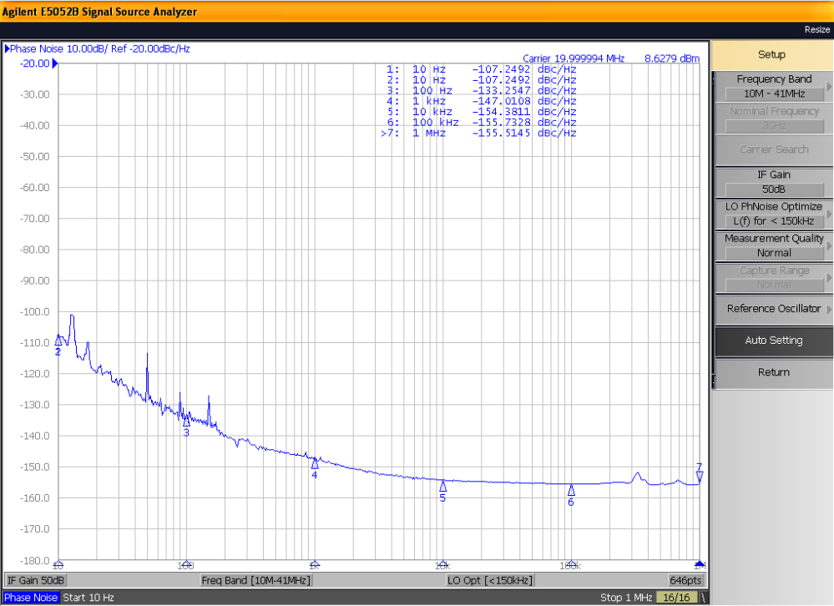

2.4温度特性曲线 Frequency Tolerance vs. Operating Temperature Range
Measuring the frequency tolerance from -40℃ to 85℃ in the temperature chamber , the temperature variable speed less than 2 ℃ per minute. The test result showed the device only have 12ppb ramping from -40℃ to 85℃ and can meet the limit requirement ,however some jitter spike was found in the temperature point for the -40℃ & 25℃ &85℃ .
Jitter spike
Temp.℃

2.5 TDEV & MTIE test
We had measured the TIE response of the device at 70℃ in the temperature chamber. We also found a 40ns spike at 750sec in the TIE data when testing G.8262 Opt2 at 70℃ const, it duplicated customer＇ finding.
TIE test data as below:
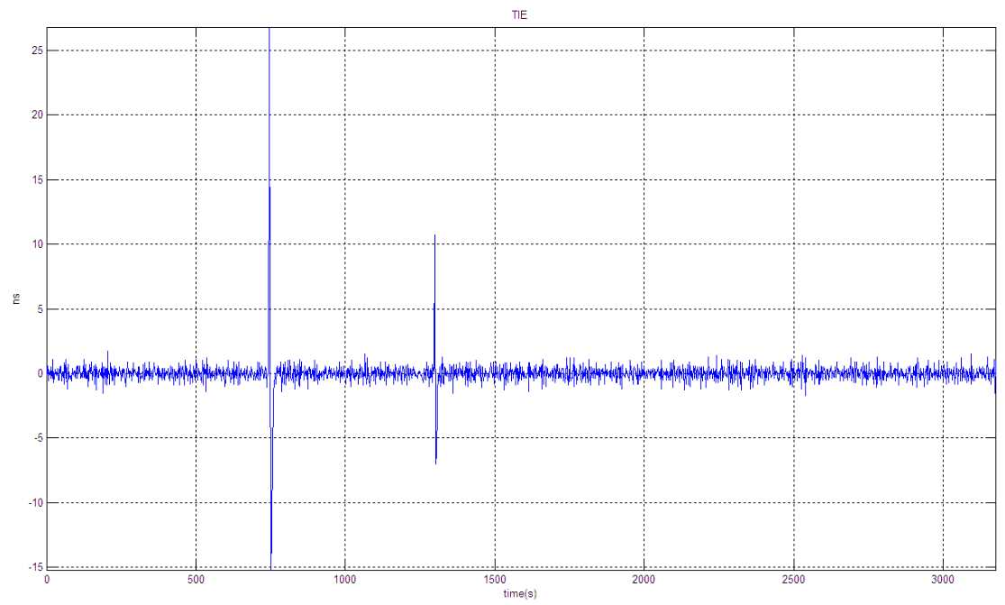

TDEV test curve as below:
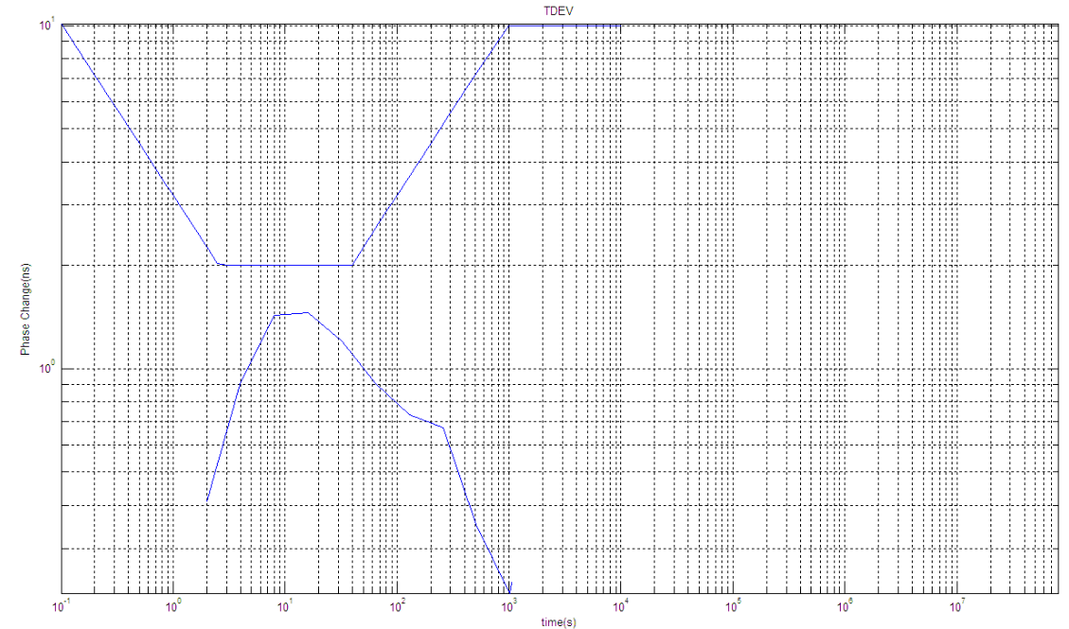
MTIE test curve as below:
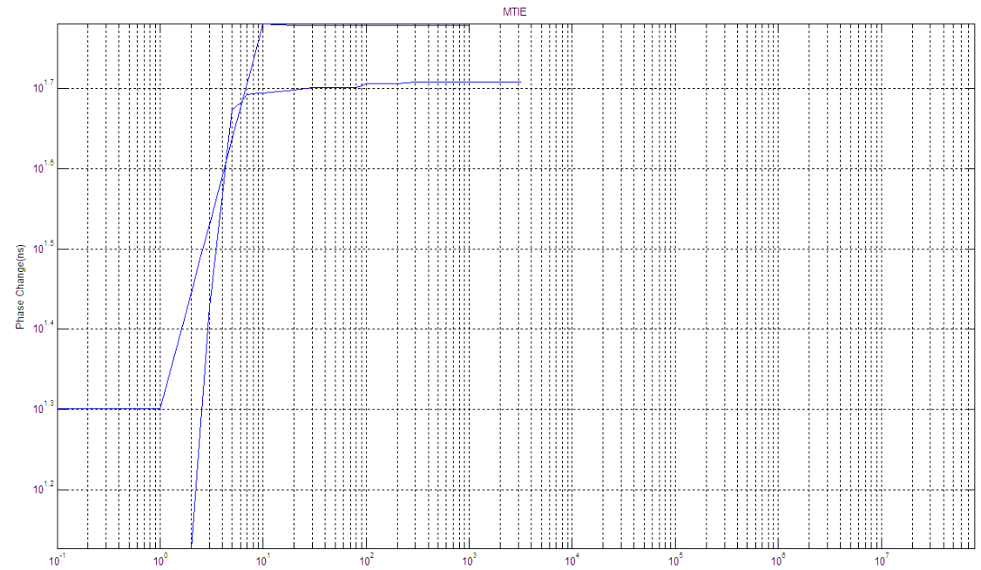
- 失效原因分析 Failure Cause Analysis
The device has some jitter spike at the frequency tolerance verification test from -40℃ to 85℃ ,the Jitter spike range can meet the specification＇requirement，but will cause the MTIE test fail in the extremity condition especially.
从TDEV 复现和温室复现数据中可以看出产品在70℃时，存在1E-8的频率突跳情况，满足产品温度稳定度要求≤±5E-8。
根本原因分析 Root Cause Analysis
The product has constant temperature and digital compensation module to achieve high stability performance. The digital compensation module of product will provide different compensation level based on ambient temperature variations during insulation work. There have a large number of different digital compensations will cause the frequency become instability and appear jitter spike in the extremity condition , the instability frequency and jitter spike cause the product fail in the MTIE test.
因为产品的设计为恒温+数字补偿方案实现高稳定度，产品在保温过程中会存在环境温度的晃动，然而产品的随着环境温度的改变，输出不同的数字补偿量，从而由量化干扰引起了频率的突变。
围堵计划/ 临时措施  Containment Plan ( Temporary Action ) |  |  |  |  | 谁  Who |  |  | 实施时间  Implement Date | 实施验证Verification |  |  | 谁 Who |  |  |  | 验证时间  Verificate Date
- 出货前，进行温室老化测试  100% of product will achieve aging test under operating temperature range before the final test.  - 出货前，对测试进行TDEV验证测试  100% of product will achieve the TDEV verification test in the final test before shipping. |  |  |  |  | Luosg  Luosg |  |  | 2017/6/22  2017/6/22 | Ongoing  Ongoing |  |  | Jim.chen |  |  |  | 2017/6/26
长期措施Permanent Corrective Actions ( Long Term ) |  |  |  |  | Owner负责人 |  |  | 时间 Date | 状态  Status |  |  | Verification  验证/确定 |  |  |  | 时间 Date
优化设计方案，去掉数字补偿部分  Optimize the design scheme and eliminate the digital compensation part。 |  |  |  |  | 周文 |  |  | 2017/6/24 | Ongoing |  |  | Jim.chen |  |  |  | 2017/6/27
标准化/防止再发生 Standardization / Prevention of Recurrence
标准化/防止再发生 Standardization / Prevention of Recurrence |  |  |  |  |  |  |  |  |  |  |  |  |  | 谁 Who |  |  | 时间 Date
NA
祝贺团队 Congratulation Your Team
祝贺团队 Congratulation Your Team |  |  |  |  |  |  |  |  |  |  |  |  |  | 谁 Who |  |  | 时间Date
周文、罗胜贵、王春明、李洪润、程国华，李自豪，陈京武 |  |  |  |  |  |  |  |  |  |  |  |  |  | 陈京武 |  |  | 20170614

Prepared 草拟：陈京武 Reviewed 审核：周文 Approved批准： 李洪润

