W/DP RD-Q4187-01-A1

Customer Code :

DAPU P/N:

Customer P/N:

DAPU |  |  | Customer Approval
Drew | Audited | Approved | Stamp, please! Thanks!
Date： |  |  | Stamp, please! Thanks!

Guangdong Dapu Telecom Technology Co.,Ltd

Bldg13-16,.N.Ind.Zone,SSL Industry Park, Dongguan City, Guangdong Province, China
TEL：0086-0769-88010888 FAX：0086-0769-81800098

DATASHEET

Table of amendment
Version | Revision contents | Prepared by | Revised  date
1.0 | ssss | sss | sss
1.1 | ssss | sss | sss
1.2 | ssss | sss | sss
1.3 | 222

1. Electrical Parameters
MODEL：
Item | Description | Parameters |  |  | Unit | Test Condition
Item | Description | Min. | Typ. | Max. | Unit | Test Condition
Output | Frequency | 10 |  |  | MHz
Output | Output Waveform | HCMOS
Output | Output Low Voltage | s |  | s | V | V_{cc}=XXV, O_{load}=15 pF
Output | Output High Voltage | s |  | s | V | V_{cc}=XXV, O_{load}=15 pF
Output | Duty Cycle | s |  | s | % | @50%
Output | Rise / Fall Time （10%~90%） | 1 |  | 1 | ns | @25℃
Output | Load |  |  |  | pF
Frequency Stabilities | Frequency Tolerance vs. Operating Temperature Range | a |  | b | ×10⁻⁶ | T_{A} varied from XX℃ toXX℃, measurement referenced to frequency observed with T_{A} = 25℃, V_{cc}= XXV, V_{c}=XXV, O_{load}= 15pF/50Ω/10KΩ//10pF, temperature variable speed less than 2℃per minute.
Frequency Stabilities | Initial Frequency Tolerance | s |  | 3 | ×10⁻⁶ | Measurement referenced to frequency observed with T_{A} = 25℃, V_{cc}= XXV, V_{c}=XXV within 30 days after ex  -works.
Frequency Stabilities | Reflow shift | s |  |  |  | 1 hour after reflow.
Frequency Stabilities | Slope | s |  |  |  | Temperature ramp 1°C/minute.
Frequency Stabilities | Frequency Tolerance vs. Supply Voltage |  |  | 3 | ×10⁻⁶ | measurement referenced to frequency observed T_{A}=25℃, V_{cc} varied from XXV to XXV, V_{c}=XXV and
Frequency Stabilities | Frequency Tolerance vs. Load |  |  | 3 | ×10⁻⁶ | 5% load change measurement referenced to frequency observed with T_{A}= 25℃, V_{cc}=XXV, V_{c}=XXV, O_{Load}= 15pF/50Ω/10KΩ//10pF
Frequency Stabilities | Retrace |  |  |  | ×10⁻⁹
Frequency Stabilities | Aging Tolerance Per Day |  |  |  | ×10⁻⁶ | T_{A}=25℃, V_{cc}=XXV, V_{c}=XXV and after 1h of operation.
Frequency Stabilities | Aging Tolerance 1 Year |  |  |  | ×10⁻⁶ | T_{A}=25℃, V_{cc}=XXV, V_{c}=XXV and after 1h of operation.
Frequency Stabilities | Overall Stability |  |  |  | ×10⁻⁶ | Inclusive of the following:  - initial tolerance (T_{A}=25℃)  - operating temperature  -XX℃ to XX℃  - 3.3V±5%  - XX load ±5%  - 2 times reflow soldering  - XX years aging
Power Supply | Current Consumption |  |  | 1 | mA | @25℃, V_{cc}=XXV, V_{c}=XXV, O_{Load}= 15pF/50Ω/10KΩ//10pF .
Power Supply | Supply Voltage |  |  |  | V
Power Supply | Warm-Up Time |  |  |  | minutes | @25℃within ±XX×10 6 of final frequency with reference after XX hours on.
Voltage Control Characteristics | Frequency Tuning Range | 1 |  | 1 | ×10⁻⁶ | V_{c}=XXV. measurement referenced to Vc=XXV
Voltage Control Characteristics | Frequency Tuning Range | 2 |  | 2 | ×10⁻⁶ | V_{c}=XXV. measurement referenced to exactly XX.XXMHz
Voltage Control Characteristics | Frequency Tuning Range | 3 |  | 3 | ×10⁻⁶ | V_{c}=XXV. measurement referenced to exactly XX.XXMHz
Voltage Control Characteristics | Linearity | s |  | 10 | %
Voltage Control Characteristics | Slope
Voltage Control Characteristics | Input Impedance | s |  |  | KΩ
Phase Noise | Phase Noise @25℃ |  | -XX | -XX | dBc/Hz | 10Hz
Phase Noise | Phase Noise @25℃ |  | -XX | -XX | dBc/Hz | 100Hz
Phase Noise | Phase Noise @25℃ | s | -XX | -XX | dBc/Hz | 1KHz
Phase Noise | Phase Noise @25℃ | s | -XX | -XX | dBc/Hz | 10KHz
Phase Noise | Phase Noise @25℃ | s | -XX | -XX | dBc/Hz | 100KHz
Phase Noise | Phase Noise @25℃ | s | -XX | -XX | dBc/Hz | 1MHz
Environmental Conditions | Operable Temperature | s |  |  | ℃
Environmental Conditions | Storage Temperature | s |  |  | ℃
Environmental Conditions | ESD Level | Human Body Model,class2: 2000V to 4000V; ANSI/ESDA/JEDEC JS-001-2010.
Environmental Conditions | ESD Level | Machine Model, class B: 200V to 400V; ANSI/ESDA/JEDEC JS-001-2010.
Environmental Conditions | Moisture Sensitivity Level | Level 2. / Not humidity sensitive.
Environmental Conditions | Vibration | Test Condition: 0.75mm ;acceleration:10g;10Hz～2000Hz, one cycle per 30 min, test 2 hour. (3 times for each 3 directions X ,Y , Z) .IEC 68-2-06 Test Fc.
Environmental Conditions | Shock | 100g; 6ms; half sine wave (3 times for each 3 directions X ,Y, Z ),IEC 68-2-27 Test Ea/Severity 50A.
Full Package Storage | Relative humidity (%) | 20%～70%

- Mechanical Structure(mm)
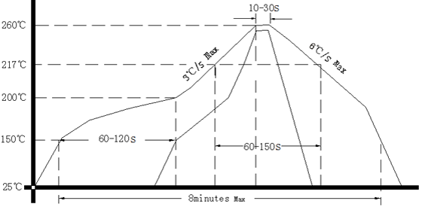
Note1: Tolerance ±0.20mm without mark
Note2: The first two xx representative: week After two xx representative: year
Note3: Referential Weight 0.2g
Note4: NC is not connect
- Test circuit
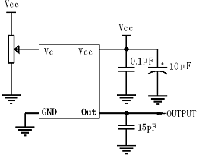
- Reflow Soldering Curve (RoHS)
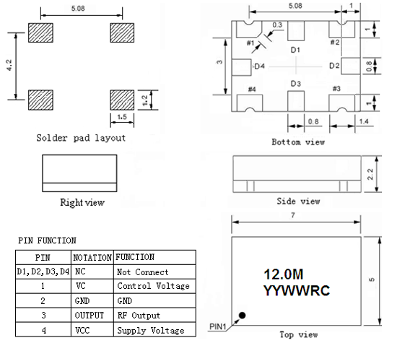
Note4: If soldering with a hot air gun, ensure the temperature ＜320℃ ，soldering time ＜15 seconds.
- Package: Tape & Reel (mm)
