W/DP RD-Q4187-01-A1

Customer Code :

DAPU P/N: O22B-O428-100.00MHz-A

Customer P/N:

DAPU |  |  | Customer Approval
Drew | Audited | Approved | Stamp, please! Thanks!
Date：2015.12.10 |  |  | Stamp, please! Thanks!

Guangdong Dapu Telecom Technology Co.,Ltd

Bldg 16,.N.Ind.Zone,SSL Industry Park, Dongguan City, Guangdong Province, China
TEL：0086-0769-88010888 FAX：0086-0769-81800098

DATASHEET

Table of amendment
Version | Revision contents | Prepared by | Revised  date
1.0 | The first issued | Amway | 2015.12.10

- Electrical Parameters
MODEL： O22B-O428-100.00MHz-A
Item | Description | Parameters |  |  | Unit | Test Condition
Item | Description | Min. | Typ. | Max. | Unit | Test Condition
Output | Frequency | 100.00 |  |  | MHz
Output | Output Waveform | Sine wave
Output | Level | 8 | 13 |  | dBm
Output | Load | 50 |  |  | Ω
Output | Harmonics Suppression |  |  | -50 | dBc
Output | Spurious Suppression |  |  | -80 | dBc
Frequency Stabilities | Frequency Tolerance  vs. Operating  Temperature Range | -0.05 |  | +0.05 | ×10⁻⁶ | T_{A} varied from-40℃ to 75℃, measurement referenced to frequency observed with f_{ref}=(f_{max}+f_{min} )/2, V_{cc}=5.0V, V_{c}=2.25V,  O_{load}=50Ω, temperature variable speed less than 2℃per minute.
Frequency Stabilities | Initial Frequency  Tolerance | -0.1 |  | +0.1 | ×10⁻⁶ | Measurement referenced to frequency observed with T_{A}=25℃, V_{cc}=5.0V, V_{c}=2.25V and after 15 minutes of operation, within 30 days after ex-works.
Frequency Stabilities | Frequency Tolerance vs. supply voltage | -5 |  | +5 | ×10⁻⁹ | measurement referenced to frequency observed T_{A}=25℃, V_{cc} varied from 4.75V to 5.25V,  V_{c}=2.25V, O_{load}=50Ω.
Frequency Stabilities | Frequency Tolerance vs. Load | -5 |  | +5 | ×10⁻⁹ | 5% Load Change Measurement referenced to frequency observed with T_{A}=25℃, V_{cc}=5.0V,  V_{c}=2.25V, O_{load}=50Ω.
Frequency Stabilities | Short Term Stability |  |  | 0.01 | ×10⁻⁹ | Temperature stability, no EMI\EMC or other interference, test after power for 1hour ref. to 25℃; 1s, using PN9000 equipment.
Frequency Stabilities | Aging Tolerance  per day | -1 |  | +1 | ×10⁻⁹ | V_{cc},V_{c}, T_{A} constant Measurement referenced to frequency observed with T_{A}=25℃,V_{cc}=5.0V,  V_{c}=2.25V, O_{load}=50Ω and after 30 days of operation.
Frequency Stabilities | Aging Tolerance  1Year | -0.1 |  | +0.1 | ×10⁻⁶
Power Supply | Supply Voltage | 4.75 | 5.0 | 5.25 | V
Power Supply | Steady Consumption |  |  | 400 | mA | @25℃
Power Supply | Warm up current |  |  | 900 | mA
Power Supply | Warm-Up Time |  |  | 5 | min | @25℃within ±0.1×10⁻⁶ of final frequency with reference after 1 hour on.
Power Supply | Vref out |  | 4.5 |  | V

Voltage  Control Characteristics | Frequency Tuning Range |  |  | -0.5 | ×10⁻⁶ | V_{c}=0V. measurement referenced to  V_{c}=2.25V.
Voltage  Control Characteristics | Frequency Tuning Range | -0.1 |  | +0.1 | ×10⁻⁶ | V_{c}=2.25V. measurement referenced  to exactly 100.00MHz.
Voltage  Control Characteristics | Frequency Tuning Range | +0.5 |  |  | ×10⁻⁶ | V_{c}=4.5V. measurement referenced to  V_{c}=2.25V.
Voltage  Control Characteristics | Linearity |  |  | 10 | %
Voltage  Control Characteristics | Slope | Positive
Voltage  Control Characteristics | Input Impedance | 100 |  |  | KΩ
Phase Noise | Phase Noise  @25℃ |  | -110 | -105 | dBc/Hz | 10Hz
Phase Noise | Phase Noise  @25℃ |  | -140 | -135 | dBc/Hz | 100Hz
Phase Noise | Phase Noise  @25℃ |  | -165 | -160 | dBc/Hz | 1KHz
Phase Noise | Phase Noise  @25℃ |  | -176 | -172 | dBc/Hz | 10KHz
Phase Noise | Phase Noise  @25℃ |  | -180 | -178 | dBc/Hz | 100KHz
Phase Noise | Phase Noise  @25℃ |  | -180 | -178 | dBc/Hz | 1MHz
Environmental  Conditions | Operable Temperature | -40 |  | +85 | ℃
Environmental  Conditions | Storage Temperature | -55 |  | +105 | ℃
Environmental  Conditions | ESD Level | Human Body Model, class2: 2000V to 4000V; ANSI/ESDA/JEDEC JS-001-2010.
Environmental  Conditions | ESD Level | Machine Model, class B: 200V to 400V; ANSI/ESDA/JEDEC JS-001-2010.
Environmental  Conditions | Moisture Sensitivity Level | Not humidity sensitive.
Environmental  Conditions | Vibration | Test Condition: 0.75mm ;acceleration:10g;10Hz～500Hz, one cycle per 30 min, test 2 hour. (3 times for each 3 directions X ,Y , Z)，IEC 68-2-06 Test Fc.
Environmental  Conditions | Shock | 50g；11ms；half sine wave (3 times for each 3 directions X ,Y, Z ),IEC 68-2-27 Test Ea/Severity 50A.
Full Package Storage | Relative humidity (%) | 20%～70%
Full Package Storage | Temperature (℃) | -10~35℃

2． Mechanical Structure (mm)
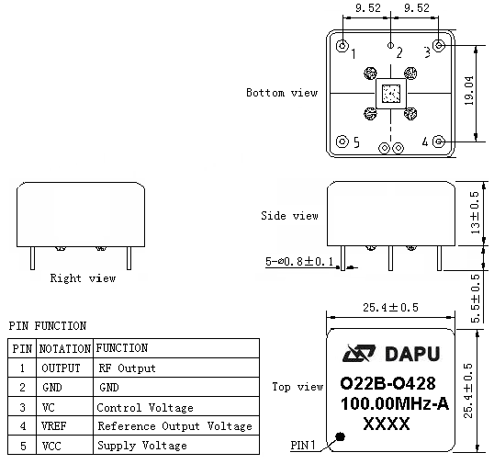
Note1: Tolerance ± 0.20mm without mark
Note2: The first two xx representative: week
After two xx representative: year
Note3: Referential Weight 13.6g

- Test Circuit
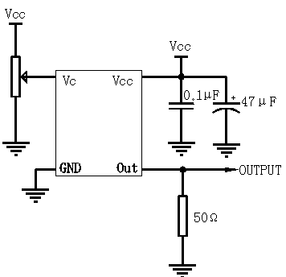
- Reflow Soldering Curve (RoHS)
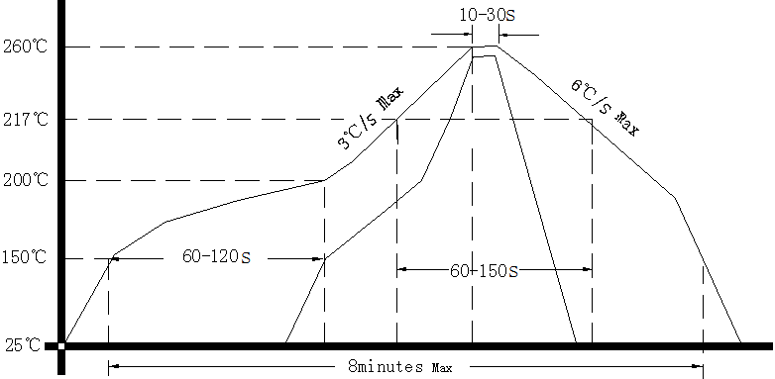
- Package(mm)
