W/DP RD-Q4187-01-A1

Customer Code :

DAPU P/N: O11E-K316-40.00MHz

Customer P/N:

DAPU |  |  | Customer Approval
Drew | Audited | Approved | Stamp, please! Thanks!
Date：2015.12.11 |  |  | Stamp, please! Thanks!

Guangdong Dapu Telecom Technology Co.,Ltd

Bldg 16,.N.Ind.Zone,SSL Industry Park, Dongguan City, Guangdong Province, China
TEL：0086-0769-88010888 FAX：0086-0769-81800098

DATASHEET

The Parameter of Product

Table of amendment
Version | Revision contents | Prepared by | Revised  date
1.0 | The first issued | Amway | 2015.12.11

- Electrical Parameters
MODEL： O11E-K316-40.00MHz
Item | Description |  | Parameters |  |  |  | Unit |  | Test Condition
Item |  |  | Min. | Typ. | Max.
Output | Frequency |  | 40.00 |  |  |  |  | MHz
Output | Output Waveform |  | HCMOS
Output | Output Low Voltage |  |  |  | 0.4 |  | V |  | V_{cc}=3.3V, O_{load}=15pF
Output | Output High Voltage |  | 2.4 |  |  |  | V |  | V_{cc}=3.3V, O_{load}=15pF
Output | Duty Cycle |  | 40 | 50 | 60 |  | % |  | @50%
Output | Rise / Fall Time  (10%~90%) |  |  |  | 10 |  | ns
Output | Load |  | 15 |  |  |  | pF
Frequency Stabilities | Frequency Tolerance vs. Operating  Temperature Range |  | -0.01 |  | +0.01 |  |  | ×10⁻⁶ | T_{A} varied from-40℃ to 85℃, measurement referenced to frequency observed with f_{ref}=(f_{max}+f_{min} )/2, V_{cc}=3.3V, V_{c}=1.65V,  O_{load}=15pF, temperature variable speed less than 2℃per minute.
Frequency Stabilities | Initial Frequency  Tolerance |  | -0.1 |  | +0.1 |  |  | ×10⁻⁶ | Measurement referenced to frequency observed with T_{A}=25℃, V_{cc}=3.3V, V_{c}=1.65V, and after 15 minutes of operation, within 30 days after ex-works.
Frequency Stabilities | Frequency Tolerance  vs. Supply Voltage |  | -5 |  | +5 |  |  | ×10⁻⁹ | measurement referenced to frequency observed T_{A}=25℃, V_{cc} varied from 3.13V to 3.47V, V_{c} =1.65V and O_{Load}=15pF.
Frequency Stabilities | Frequency Tolerance  vs. Load |  | -5 |  | +5 |  |  | ×10⁻⁹ | 5% load change measurement referenced to frequency observed with T_{A}=25℃, V_{cc}=3.3V, V_{c}=1.65V, and O_{Load}=15pF.
Frequency Stabilities | Short-Term Stability: Allan Variance |  |  |  | 0.01 |  |  | ×10⁻⁹ | Temperature stability, no EMI\EMC or other interference，test after power for 1hour ref. to 25℃; 1s, using PN9000 equipment.
Frequency Stabilities | Aging Tolerance  Per Day |  | -1 |  | +1 |  |  | ×10⁻⁹ | V_{cc}, V_{c}, T_{A} constant measurement referenced to frequency observed with T_{A}=25℃, V_{cc}= 3.3V, V_{c}=1.65V and after 30 days of operation.
Frequency Stabilities | Aging Tolerance  1 Year |  | -0.1 |  | +0.1 |  |  | ×10⁻⁶
Power Supply | Supply Voltage |  | 3.13 | 3.3 | 3.47 |  |  | V
Power Supply | Steady Consumption |  |  |  | 350 |  |  | mA | @25℃
Power Supply | Warm up current |  |  |  | 750 |  |  | mA
Voltage  Control Characteristics |  | Frequency Tuning Range | -1 |  | -0.5 | ×10⁻⁶ |  |  | V_{c}=0V. measurement referenced to  V_{c}=1.65V
 |  | Frequency Tuning Range | -0.1 |  | +0.1 | ×10⁻⁶ |  |  | V_{c}=1.65V. measurement referenced to  Exactly 40.00MHz
 |  | Frequency Tuning Range | +0.5 |  | +1 | ×10⁻⁶ |  |  | V_{c}=3.3V. measurement referenced to  V_{c}=1.65V
 |  | Linearity |  |  | 10 | %
 |  | Slope | Positive
 |  | Input Impedance | 100 |  |  | KΩ
Phase Noise |  | Phase Noise  @25℃ |  | -110 | -100 | dBc/Hz |  |  | 10Hz
 |  | Phase Noise  @25℃ |  | -130 | -120 |  |  |  | 100Hz
 |  | Phase Noise  @25℃ |  | -140 | -135 |  |  |  | 1KHz
 |  | Phase Noise  @25℃ |  | -145 | -140 |  |  |  | 10KHz
 |  | Phase Noise  @25℃ |  | -150 | -145 |  |  |  | 100KHz
 |  | Phase Noise  @25℃ |  | -150 | -145 |  |  |  | 1MHz
Environmental  Conditions |  | Operable Temperature | -40 |  | +85 | ℃
 |  | Storage  Temperature | -55 |  | +105 | ℃
 |  | ESD Level | Human Body Model, class2: 2000V to 4000V; ANSI/ESDA/JEDEC JS-001-2010.
 |  | ESD Level | Machine Model, class B: 200V to 400V; ANSI/ESDA/JEDEC JS-001-2010.
 |  | Moisture  Sensitivity Level | Level 2.
 |  | Vibration | Test Condition: 0.75mm ;acceleration:10g;10Hz～500Hz, one cycle per 30 min, test 2 hour. (3 times for each 3 directions X ,Y , Z), IEC 68-2-06 Test Fc.
 |  | Shock | 50g; 11ms; half sine wave (3 times for each 3 directions X, Y, Z), IEC 68-2-27 Test Ea/Severity 50A.
Full Package Storage |  | Relative humidity (%) | 20%～70%
 |  | Temperature (℃) | -10~35℃

2． Mechanical Structure (mm)
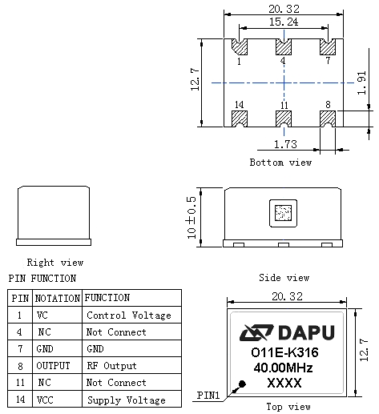
Note1: Tolerance ± 0.20mm without mark
Note2: The first two xx representative: week
After two xx representative: year
Note3: Referential Weight 8.0g
Note4: NC is not connect
3．Test Circuit
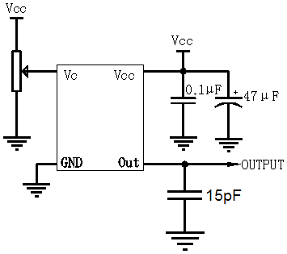
4. Reflow Soldering Curve (RoHS)
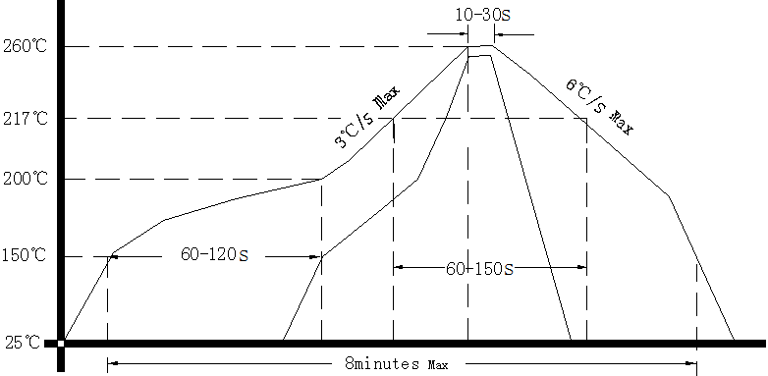
5. Package: Tape & Reel (mm)
