W/DP RD-Q4187-01-A1

Customer Code :

DAPU P/N: O23B-L446-100.00MHz-A

Customer P/N:

DAPU |  |  | Customer Approval
Drew | Audited | Approved | Stamp, please! Thanks!
Date：2015.12.15 |  |  | Stamp, please! Thanks!

Guangdong Dapu Telecom Technology Co.,Ltd

Bldg 16,.N.Ind.Zone,SSL Industry Park, Dongguan City, Guangdong Province, China
TEL：0086-0769-88010888 FAX：0086-0769-81800098

DATASHEET

Table of amendment
Version | Revision contents | Prepared by | Revised  date
1.0 | The first issued | Amway | 2015.12.15

- Electrical Parameters
MODEL：O23B-L446-100.00MHz-A
Item | Description |  | Parameters |  |  | Unit |  | Test Condition
Item |  |  | Min. | Typ. | Max. |  |  | Test Condition
Output | Frequency |  | 100.00 |  |  | MHz
Output | Output Waveform |  | Sine wave
Output | Level |  | 6 |  |  | dBm
Output | Load |  | 50 |  |  | Ω
Output | Harmonics Suppression |  |  |  | -30 | dBc
Output | Spurious Suppression |  |  |  | -60 | dBc
Frequency Stabilities | Frequency Tolerance  vs. Operating  Temperature Range |  | -5 |  | +5 | ×10⁻⁹ |  | T_{A} varied from-20℃ to 70℃, measurement referenced to frequency observed with f_{ref}=(f_{max}+f_{min} )/2, V_{cc}=12.0V, V_{c}=2.5V,  O_{load}=50Ω, temperature variable speed less than 2℃per minute.
Frequency Stabilities | Initial Frequency  Tolerance |  | -0.3 |  | +0.3 | ×10⁻⁶ |  | Measurement referenced to frequency observed with T_{A}=25℃, V_{cc}=12.0V, V_{c}=2.5V and after 15 minutes of operation, within 30 days after ex-works.
Frequency Stabilities | Frequency Tolerance vs. supply voltage |  | -5 |  | +5 | ×10⁻⁹ |  | measurement referenced to frequency observed T_{A}=25℃, V_{cc} varied from 11.4V to 12.6V, V_{c}=2.5V, O_{load}=50Ω.
Frequency Stabilities | Frequency Tolerance vs. Load |  | -5 |  | +5 | ×10⁻⁹ |  | 5% Load Change Measurement referenced to frequency observed with T_{A}=25℃, V_{cc}=12.0V, V_{c}=2.5V, O_{load}=50Ω.
Frequency Stabilities | Short Term Stability |  |  |  | 0.01 | ×10⁻⁹ |  | Temperature stability, no EMI\EMC or other interference, test after power for 1hour ref. to 25℃; 1s, using PN9000 equipment.
Frequency Stabilities | Aging Tolerance  per day |  | -1 |  | +1 | ×10⁻⁹ |  | V_{cc},V_{c}, T_{A} constant Measurement referenced to frequency observed with T_{A}=25℃,  V_{cc}=12.0V, V_{c}=2.5V, O_{load}=50Ω and after 30 days of operation.
Frequency Stabilities | Aging Tolerance  1Year |  | -0.1 |  | +0.1 | ×10⁻⁶
Power Supply | Supply Voltage |  | 11.4 | 12.0 | 12.6 | V
Power Supply | Steady Consumption |  |  |  | 300 | mA |  | @25℃
Power Supply | Warm up current |  |  |  | 600 | mA
Voltage  Control Characteristics |  | Frequency Tuning Range |  |  | -0.5 |  | ×10⁻⁶ | V_{c}=0V. measurement referenced to  V_{c}=2.5V.
 |  | Frequency Tuning Range | -0.3 |  | +0.3 |  | ×10⁻⁶ | V_{c}=2.5V. measurement referenced  to exactly 100.00MHz.
 |  | Frequency Tuning Range | +0.5 |  |  |  | ×10⁻⁶ | V_{c}=5.0V. measurement referenced to  V_{c}=2.5V.
 |  | Linearity |  |  | 10 |  | %
 |  | Slope | Positive
 |  | Input Impedance | 100 |  |  |  | KΩ
Phase Noise |  | Phase Noise  @25℃ |  | -110 | -105 |  | dBc/Hz | 10Hz
 |  | Phase Noise  @25℃ |  | -140 | -135 |  | dBc/Hz | 100Hz
 |  | Phase Noise  @25℃ |  | -155 | -150 |  | dBc/Hz | 1KHz
 |  | Phase Noise  @25℃ |  | -160 | -155 |  | dBc/Hz | 10KHz
 |  | Phase Noise  @25℃ |  | -175 | -170 |  | dBc/Hz | 100KHz
 |  | Phase Noise  @25℃ |  | -175 | -170 |  | dBc/Hz | 1MHz
Environmental  Conditions |  | Operable Temperature | -40 |  | +85 |  | ℃
 |  | Storage Temperature | -55 |  | +105 |  | ℃
 |  | ESD Level | Human Body Model, class2: 2000V to 4000V; ANSI/ESDA/JEDEC JS-001-2010.
 |  | ESD Level | Machine Model, class B: 200V to 400V; ANSI/ESDA/JEDEC JS-001-2010.
 |  | Moisture Sensitivity Level | Not humidity sensitive.
 |  | Vibration | Test Condition: 0.75mm ;acceleration:10g;10Hz～500Hz, one cycle per 30 min, test 2 hour. (3 times for each 3 directions X ,Y , Z)，IEC 68-2-06 Test Fc.
 |  | Shock | 50g；11ms；half sine wave (3 times for each 3 directions X ,Y, Z ),IEC 68-2-27 Test Ea/Severity 50A.
Full Package Storage |  | Relative humidity (%) | 20%～70%
 |  | Temperature (℃) | -10~35℃

2． Mechanical Structure (mm)
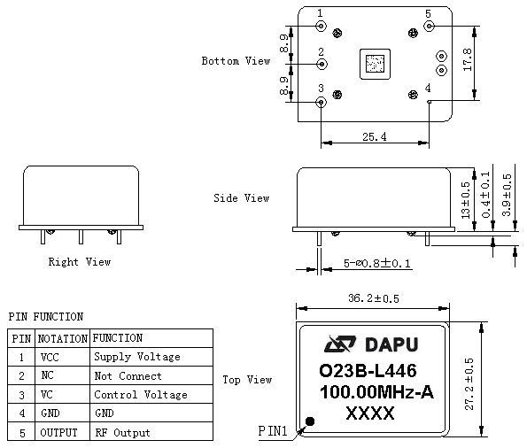
Note1: Tolerance ± 0.20mm without mark
Note2: The first two xx representative: week
After two xx representative: year
Note3: Referential Weight 20.7g

- Test Circuit
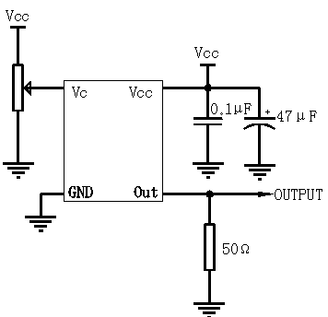
- Reflow Soldering Curve (RoHS)
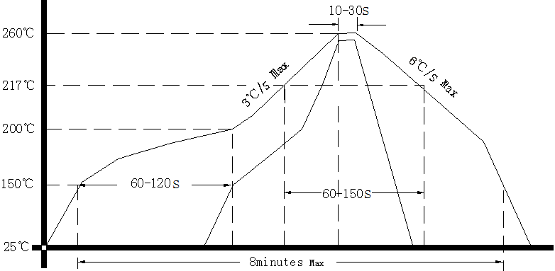
- Package(mm)
