W/DP RD-Q4187-01-A1

Customer Code :

DAPU P/N: T53-O319-20.00MHz

Customer P/N:

DAPU |  |  | Customer Approval
Drew | Audited | Approved | Stamp, please! Thanks!
Date：2015.12.22 |  |  | Stamp, please! Thanks!

Guangdong Dapu Telecom Technology Co.,Ltd

Bldg 16,.N.Ind.Zone,SSL Industry Park, Dongguan City, Guangdong Province, China
TEL：0086-0769-88010888 FAX：0086-0769-81800098

DATASHEET

Table of amendment
Version | Revision contents | Prepared by | Revised  date
1.0 | The first issued | Amway | 2015.12.22

- Electrical Parameters
MODEL： T53-O319-20.00MHz
Item | Description |  | Parameters |  |  |  |  |  |  |  | Unit |  | Test Condition
Item |  |  | Min. |  |  |  | Typ. |  | Max.
Output | Frequency |  | 20.00 |  |  |  |  |  |  |  | MHz
Output | Output Waveform |  | HCMOS
Output | Output Low Voltage |  |  |  |  |  |  |  | 0.4 |  | V |  | V_{cc}=3.3V, O_{load}=15 pF
Output | Output High Voltage |  | 2.4 |  |  |  |  |  |  |  | V |  | V_{cc}=3.3V, O_{load}=15 pF
Output | Duty Cycle |  | 45 |  |  | 50 |  |  | 55 |  | % |  | @50%
Output | Rise / Fall Time  （10%~90%） |  |  |  |  |  |  |  | 8 |  | ns |  | @25℃
Output | Load |  | 15 |  |  |  |  |  |  |  | pF
Frequency Stabilities | Frequency Tolerance vs. Operating  Temperature Range |  | -0.1 |  |  |  |  |  | +0.1 |  | ×10⁻⁶ |  | T_{A} varied from -40℃ to85℃, measurement referenced to frequency observed with T_{A}=25℃, V_{cc}=3.3V, O_{load}=15 pF , temperature variable speed less than 2℃per minute.
Frequency Stabilities | Initial Frequency  Tolerance |  | -0.5 |  |  |  |  |  | +0.5 |  | ×10⁻⁶ |  | Measurement referenced to frequency observed with T_{A}=25℃, V_{cc}=3.3V within 30 days after ex-works.
Frequency Stabilities | Frequency Tolerance vs. Supply Voltage |  | -0.05 |  |  |  |  |  | +0.05 |  | ×10⁻⁶ |  | measurement referenced to frequency observed T_{A}=25℃, V_{cc} varied from 3.13V to 3.47V and O_{Load}=15 pF .
Frequency Stabilities | Frequency Tolerance vs. Load |  | -0.05 |  |  |  |  |  | +0.05 |  | ×10⁻⁶ |  | 5% load change measurement referenced to frequency observed with T_{A}=25℃, V_{cc}=3.3V and O_{Load}=15 pF .
Frequency Stabilities | Aging Tolerance  Per Day |  | -0.02 |  |  |  |  |  | +0.02 |  | ×10⁻⁶ |  | T_{A}=25℃, V_{cc}=3.3V and after 1h of operation.
Frequency Stabilities | Aging Tolerance  1 Year |  | -1 |  |  |  |  |  | +1 |  | ×10⁻⁶
Power Supply | Operating Current |  |  |  |  |  |  |  | 10 |  | mA |  | @25℃, V_{cc}=3.3V, O_{Load}=15 pF .
Power Supply | Supply Voltage |  | 3.13 |  | 3.3 |  |  |  | 3.47 |  | V
Phase Noise |  | Phase Noise  @25℃ |  |  |  |  |  | -85 |  | -80 |  | dBc/Hz |  | 10Hz
 |  |  |  |  |  |  |  | -115 |  | -110 |  |  |  | 100Hz
 |  |  |  |  |  |  |  | -135 |  | -130 |  |  |  | 1KHz
 |  |  |  |  |  |  |  | -145 |  | -140 |  |  |  | 10KHz
 |  |  |  |  |  |  |  | -145 |  | -140 |  |  |  | 100KHz
 |  |  |  |  |  |  |  | -148 |  | -143 |  |  |  | 1MHz
Environmental  Conditions |  | Operable Temperature |  | -40 |  |  |  |  |  | +85 |  | ℃
 |  | Storage Temperature |  | -55 |  |  |  |  |  | +105 |  | ℃
 |  | ESD Level |  | Human Body Model,class2: 2000V to 4000V; ANSI/ESDA/JEDEC JS-001-2010.
 |  |  |  | Machine Model, class B: 200V to 400V; ANSI/ESDA/JEDEC JS-001-2010.
 |  | Moisture Sensitivity Level |  | Level 3.
 |  | Vibration |  | Test Condition: 0.75mm ;acceleration:10g;10Hz～2000Hz, one cycle per 30 min, test 2 hour. (3 times for each 3 directions X ,Y , Z) .IEC 68-2-06 Test Fc.
 |  | Shock |  | 100g；6ms；half sine wave (3 times for each 3 directions X ,Y, Z ),IEC 68-2-27 Test Ea/Severity 50A.
Full Package Storage |  | Relative humidity (%) |  | 20%～70%
 |  | Temperature (℃) |  | -10~35℃

- Mechanical Structure(mm)
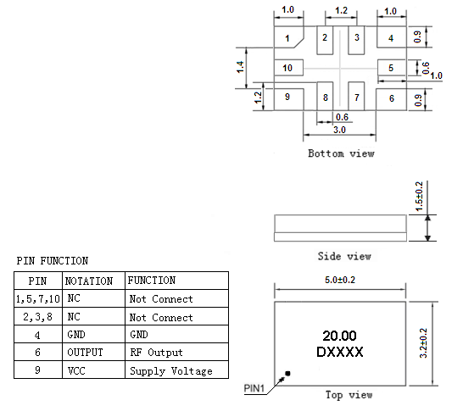
Note1: Tolerance ±0.10mm without mark
Note2: The D representative: DAPU
The first two xx representative: week
After two xx representative: year
Note3: Referential Weight 0.05g
Note4: NC is not connect

- Test Circuit
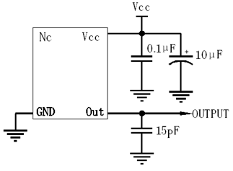
- Reflow Soldering Curve (RoHS)
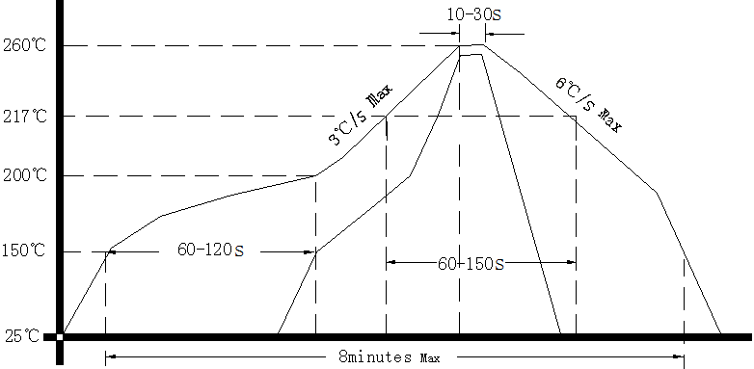
Note: If soldering with a hot air gun, ensure the temperature ＜320℃ ，soldering time ＜15 seconds.

- Package: Tape & Reel (mm)
