W/DP RD-Q4187-01-A1

Customer Code :

DAPU P/N: **CM33P-S329-10.00MHz**

Customer P/N:

|  |  |  |  |
| --- | --- | --- | --- |
| DAPU | | | Customer Approval |
| Drew | Audited | Approved | Stamp, please! Thanks! |
|  |  |  |
| Date：2015.12.15 | | |

### Guangdong Dapu Telecom Technology Co.,Ltd

Bldg 16,.N.Ind.Zone,SSL Industry Park, Dongguan City, Guangdong Province, China

TEL：0086-0769-88010888 FAX：0086-0769-81800098

DATASHEET

**Table of amendment**

|  |  |  |  |
| --- | --- | --- | --- |
| Version | Revision contents | Prepared by | Revised  date |
| 1.0 | The first issued | Amway | 2015.12.15 |
|  |  |  |  |
|  |  |  |  |
|  |  |  |  |
|  |  |  |  |
|  |  |  |  |
|  |  |  |  |
|  |  |  |  |
|  |  |  |  |
|  |  |  |  |
|  |  |  |  |
|  |  |  |  |
|  |  |  |  |
|  |  |  |  |

1. **Electrical Parameters**

|  |  |  |  |  |  |  |  |  |
| --- | --- | --- | --- | --- | --- | --- | --- | --- |
| 1 PPS Reference  Input | Parameters | | | Min. | Typ. | Max. | Unit. | Test Condition |
| Waveform | | | HCMOS | | |  |  |
| High-Level Output Voltage (VIH ) | | | 2.4 |  |  | V | 50Ω |
| Low-Level Output Voltage (VIL ) | | |  |  | 0.4 | V |
| Pulse Width | | | 10 |  |  | μs |
| Connector | | | Pin 4 | | | |  |
|  | | | | | | | | |
| SGMII  Interface | Parameters | | | Min. | Typ. | Max. | Unit. | Test Condition |
| Vi | | Input Voltage Range | 675 |  | 1725 | mV |  |
| Vidth | | Input Differential Threshold | 50 |  | 400 | mV |  |
| Vod | | Input Differential Voltage | 150 |  | 400 | mV |  |
| Rin | | Differential Input Impedance | 80 |  | 120 | Ω |  |
| DRT | | Serial Input Data Rate Tolerance | -300 |  | +300 | ppm |  |
| Voh | | Output Voltage High State |  |  | 1525 | mV |  |
| Vol | | Output Voltage Low State | 875 |  |  | mV |  |
| Vod | | Output Differential Voltage | 150 |  | 400 | mV |  |
| DR | | Serial Data Rate |  | 1.25 |  | Gbits/sec |  |
| Connector | | | Pin 26,27,28,29  Pin 35,36,37,38 | | | |  |
|  | | | | | | | | |
| RST | Parameters | | | Min. | Typ. | Max. | Unit. | Test Condition |
| Normal State | | | 2.4 |  |  | V | <5mA Load |
| Reset to Default | | |  |  | 0.4 | V | <5mA Load |
| Minimum Tine | | | 100 |  |  | ns |  |
| Connector | | | Pin 24 | | | |  |
|  | | | | | | | | |
| Holdover Capability | Holdover Time | | | Min. | Typ. | Max. | Unit. | Test Condition |
| 24 Hours | | | -44 |  | 44 | μs | △T=±5℃, 24 hours holdover after turn on and lock 3 days.  Temperature variable speed less than 1℃per minute |
|  | | | | | | | | |
| Supply Voltage | Parameters | | | Min. | Typ. | Max. | Unit. | Test Condition |
| Supply Voltage | | | 3.13 | 3.3 | 3.47 | V |  |
| Current Consumption | | |  |  | 1100 | mA | During Warm-up |
|  |  | 700 | mA | During steady state operation @25℃ |
| AC Ripple | | |  |  | 50 | mV pk-pk | 10Hz to 1MHz |
| Connector | | | Pin11 | | | |  |
|  | | | | | | | | |
| 1 PPS Output Waveform Characteristics | Parameters | | | Min. | Typ. | Max. | Unit. | Test Condition |
| Waveform | | | HCMOS | | | |  |
| High-Level Output Voltage(VOH ) | | | 2.4 |  |  | V | 50Ω |
| Low-level Output Voltage (VOL) | | |  |  | 0.4 | V |
| Pulse Width | | | 0.1 | 100 | 400 | ms |
| Phase Accuracy | | | -50 |  | 50 | ns | CM is master mode, sync with the GPS 1PPS |
| Connector | | | Pin 16 | | | |  |
|  | | | | | | | | |
| LOCK  Status Output | Parameters | | | Min. | Typ. | Max. | Unit. | Test Condition |
| Lock | | | 2.4 |  |  | V | <5mA Load |
| Free run/Holdover | | |  |  | 0.4 | V | <5mA Load |
| Connector | | | Pin 32 | | | |  |
|  | | | | | | | | |
| |  |  |  |  |  |  |  | | --- | --- | --- | --- | --- | --- | --- | | TOD | Parameters | Min. | Typ. | Max. | Unit. | Test Condition | | Rx High-level Input Voltage (VH ) | 2.4 |  |  | V |  | | Rx Low-level Input Voltage (VL) |  |  | 0.4 | V |  | | Tx High-level Output Voltage (VH ) | 2.4 |  |  | V |  | | Tx Low-level Output Voltage (VL) |  |  | 0.4 | V |  | | Serial Protocol | 4800-N-8-1 | | | |  | | Connector | Pin 17,18  Pin 19,20 | | | |  | |  | | | | | | | | | | | | | | | |
| FREQ_OUT0/  FREQ_OUT1 | | Parameters | | Min. | Typ. | Max. | Unit. | Test Condition |
| Frequency | | Time-aligned: programmable frequency 100Hz to 25MHz  Frequency-aligned: programmable frequency 1 kHz to 62.5MHz | | | |  |
| Waveform | | HCMOS | | | |  |
| High-Level Output Voltage(VOH ) | | 2.4 |  |  | V | 15pF |
| Low-level Output Voltage (VOL) | |  |  | 0.4 | V |
| Rise/Fall Time | |  |  | 8 | ns |
| Connector | | Pin 14,34 | | | |  |
|  | | | | | | | | |
| |  |  |  | | --- | --- | --- | | Environmental Conditions | Parameter | Conditions | | Operating Temperature | -20℃ to +75℃ | | Storage Temperature | -55℃ to +105℃ | | Storage Humidity | 30%~80% | | ESD Level | Human Body Model,class2: 2000V to 4000V; ANSI/ESDA/JEDEC JS-001-2010. | | Machine Model, class B: 200V to 400V; ANSI/ESDA/JEDEC JS-001-2010. | | Moisture Sensitivity Level | Not humidity sensitive. | | Vibration | Test Condition: 0.75mm ;acceleration:10g;10Hz～500Hz, one cycle per 30 min, test 2 hour. (3 times for each 3 directions X ,Y , Z)，IEC 68-2-06 Test Fc. | | Shock | 50g；11ms；half sine wave (3 times for each 3 directions X ,Y, Z ),IEC 68-2-27 Test Ea/Severity 50A. | | Full Package  Storage | Relative Humidity (%) | 20%～70% | | Temperature (℃) | -10~35℃ | | | | | | | | | |

1. **Mechanical Structure(mm)**

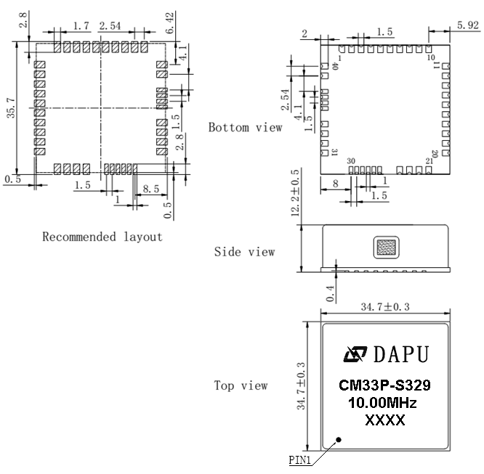

**Note1:** Tolerance **±** 0.20mm without mark

**Note2:** The first two xx representative: week

After two xx representative: year

**Pin Description**

|  |  |  |  |
| --- | --- | --- | --- |
| PIN | NAME | I/O | DESCRIPTION |
| 1 | OSC_CLK_OUTPUT | O | Suspended, reserved |
| 2 | CLK_SEL | I | System clock select:  1: the system clock use the local oscillator  0: the system clock the external reference |
| 3 | FORCE_HOLD | I | Reserved, update by software |
| 4 | 1PPS_IN | I | 1PPS input clock, it can come from GPS receiver or other 1PPS reference |
| 5,15,25,30 | GND |  | GND |
| 6 | SLVINT | O | SPI interface, The serial peripheral interface (SPI) is a slave port for communication with a serial microprocessor bus, allowing the module to be controlled by an external processor |
| 7 | SLVCSB | I |
| 8 | SLVSCLK | I |
| 9 | SLVMISO | O |
| 10 | SLVMOSI | I |
| 11 | VCC |  | VCC |
| 12,13 | NC |  | Suspended, reserved |
| 14 | FREQ_OUT0 | O | Time-aligned output pair:  125 MHz divided by n (n = 4 to 125000)  maximum of 25MHz MHz (divide by 4)  minimum of 100 Hz (divide by 1249999)  Frequency-aligned outputs:  programmable frequency 1 kHz to 62.5MHz |
| 34 | FREQ_OUT1 | O |
| 16 | 1PPS_OUT | O | The clock module 1PPS output |
| 17 | TOD1_TX | O | Time of day output interface, NMEA 0183, The UART has an integrated baud rate generator using 1 stop bit and no parity |
| 18 | TOD1_RX | I |
| 19 | TOD0_RX | I |
| 20 | TOD0_TX | O |
| 21 | MDC | O | MII CLK |
| 22 | MDIO | I/O | MII data input/output |
| 23 | OSCFSEL0 | I | Oscillator frequency select pins, which set the expected local oscillator frequency  OSCFSEL1/0=00 local oscillator frequency 20MHz  OSCFSEL1/0=01 local oscillator frequency 10MHz  OSCFSEL1/0=10 local oscillator frequency 12.8MHz |
| 33 | OSCFSEL1 | I |
| 24 | RST | I | Reset the clock module |
| 26 | SGMIITXP0 | O | PTP port 0,SGMII interface |
| 27 | SGMIITXN0 | O |
| 28 | SGMIIRXP0 | I |
| 29 | SGMIIRXN0 | I |
| 31 | FAULT | O | Fault alarm |
| 32 | LOCKED | O | State output. Output high level when the CM is locked and stable, others low level |
| 35 | SGMIIRXN1 | I | PTP port 1,SGMII interface |
| 36 | SGMIIRXP1 | I |
| 37 | SGMIITXN1 | O |
| 38 | SGMIITXP1 | O |
| 39 | FREQ_IN | I | Clock reference input. Acceptable frequencies into the PTP module from:  1 PPS/1 Hz to 161MHz (input reference for PTP Master)  The input frequencies must obey the following rule:  Input Freq = k * 2^n, where 0 <= n <= 5 and 1 <= k <= 2^32 (upper limit of 170 MHz) |
| 40 | EXT_CLK | I | External clock , back up for the local oscillator (support frequency 10MHz,12.8MHz,20MHz） |

1. **Application Information**

Typical application 1



Typical application 2



1. **Coding Rules**

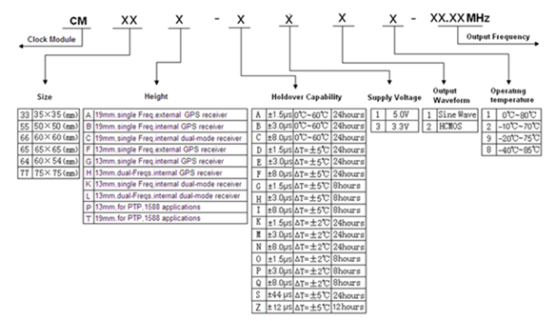

1. **Reflow** **Soldering Curve (RoHS)**

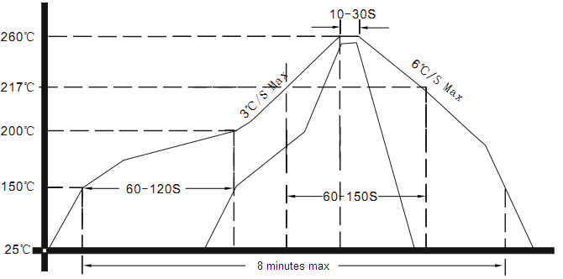

1. **Package（mm）**

