W/DP RD-Q4187-01-A0

Customer Name:

Standard: RM-7202-868

P/N:

Plot |  |  | The Label
Drew | Audited | Approved | Stamp, please! Thanks!
Date： |  |  | Stamp, please! Thanks!

Guangdong Dapu Telecom Technology Co.,Ltd

Bldg16,.N.Ind.Zone,SSL Industry Park, Dongguan City, Guangdong Province, China
TEL：0086-0769-88010888 FAX：0086-0769-81800098

The Parameter of Product
1. Running Parameters
MODEL ： RM-7202-868
Description |  | Parameters |  |  | Unit | Test Condition
 |  | Min. | Typ. | Max. | Unit | Test Condition
Supply voltage |  | 1.8 | 3.3 | 3.7 | V
Operational temperature range |  | -40 |  | 85 | ℃
Power consumption | Sleep Idle |  | 2 |  | uA
Power consumption | Standby |  | 2 |  | mA
Power consumption | Receive Mode |  | 12 |  | mA
Power consumption | Transmit Mode |  | 110 |  | mA
Crystal oscillator frequency |  |  | 32 |  | MHz
Modulation |  | FSK/LoRa
Frequency Range |  | 868 |  |  | MHz
Spread Frequency |  | 6 |  | 12
Bandwidth |  | 125 |  | 500 | KHz
Effective Bitrate |  | 0.24 |  | 37.5 | kbps
Est. sensitivity |  | -117 |  | -137 | dBm
RF output power |  | 10 |  | 19 | dBm
Packet engine |  | 256 bytes with CRC
Transceiver |  | SX1272
MCU |  | STM32F412RGT6

2. Pin Diagram
 | Connected pin No.
RF Board | SX1272 | STM32F412RGT6 | Pin definition | Description
 | 6 | 37 | RESET_sx | Reset trigger input
 | 9 | 29 | RF_DIO0 | Digital I/O
 | 10 | 28 | RF_DIO1 | Digital I/O
 | 11 | 27 | RF_DIO2 | Digital I/O
 | 12 | 26 | RF_DIO3 | Digital I/O
 | 13 | 25 | RF_DIO4 | Digital I/O
 | 14 | 24 | RF_DIO5 | Digital I/O
 | 17 | 21 | RF_SCK | SPI Clock input
 | 18 | 22 | RF_MISO | SPI Data output
 | 19 | 23 | RF_MOSI | SPI Data input
 | 20 | 20 | RF_NSS | SPI Chip select input
1 |  | 57 | PB5 | GPIOB_PB5
2 |  | 58 | PB6/I2C1_SCL | I2C1_SCL
3 |  | 59 | PB7/I2C1_SDA | I2C1_SDA
4 |  | 61 | PB8/I2C1_SCL | I2C1_SCL
5 |  | 62 | PB9/I2C1_SDA | I2C1_SDA
6 |  | 1 | VBAT | VBAT+
7 |  | 2 | PC13 | GPIOC_PC13
8 |  | 8 | PC0/ADC1_10 | PC0_ADC1
9 |  | 9 | PC1/ADC1_11 | PC1_ADC1
10 |  | 10 | PC2/ADC1_12 | PC2_ADC1
11 |  | 11 | PC3/ADC1_13 | PC3_ADC1
12 |  | 14 | PA0/ADC1_0 | PA0_ADC1
13 |  | 15 | PA1/ADC1_1 | PA1_ADC1
14 |  | 16 | PA2/ADC1_2 | PA2_ADC1
15 |  | 12 | GND | GND
16 |  | 19 | VDD-3.3V | VDD-3.3V
17 |  | 33 | PB12/SPI2_NSS | SPI2_NSS
18 |  | 34 | PB13/SPI2_SCK | SPI2_SCK
19 |  | 35 | PB14/SPI2_MISO | SPI2_MISO
20 |  | 36 | PB15/SPI2_MOSI | SPI2_MOSI
21 |  | NC | NC | NC
22 |  | 38 | PC7 | GPIO
23 |  | 39 | PC8 | GPIOC_PC8
24 |  | 40 | PC9 | GPIOC_PC9
25 |  | 41 | PA8 | GPIOA_PA8
26 |  | 42 | PA9/USART1_TX | USART1_TX
27 |  | 43 | PA10/USART1-RX | USART1-RX
28 |  | 47 | GND | GND
29 |  | 44 | PA11/USART6_TX | USART6_TX
30 |  | 45 | PA12/USART6_RX | USART6_RX
31 |  | 51 | PC10/USART3_TX | USART3_TX
32 |  | 52 | PC11/USART3_RX | USART3_RX
33 |  | 54 | PD2 | GPIOD_PD2
34 |  | 53 | PC12 | GPIOC_PC12
35 |  | 46 | JTMS-SWDIO | STM32 Download and debug port
36 |  | 49 | JTCK-SWCLK | STM32 Download and debug port
37 |  | 50 | JTDI | STM32 Download and debug port
38 |  | 55 | JTDO-SWO | STM32 Download and debug port
39 |  | 56 | JTRST | STM32 Download and debug port
40 |  | 7 | NRST | STM32 Download and debug port
41 |  | 63 | GND | GND

3. Size Dimension
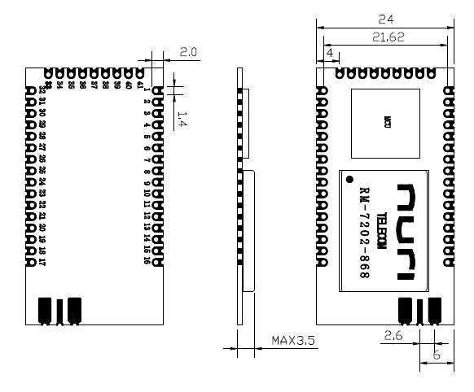

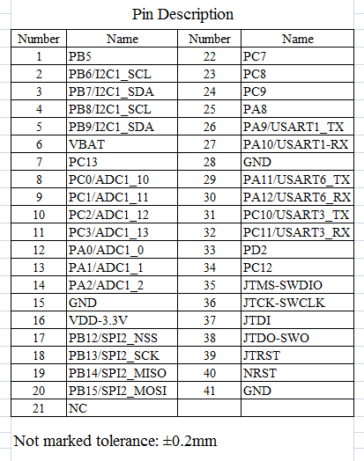

4. Product model description
72
R M
02
868

'868' means the Frequency Range
'00' means no MCU, other number means MCU No(or Sensor No)
Transceiver No, such as '72' means SX1272
Product type：module and end nodes
General division

MCU No. /Sensor No.
Transceiver No.

M for module & N for end nodes products

R means radio frequency products

5. Sample test results table
TX Test |  |  |  |  |  | RX Test
Frequency | Setting Power | Transmit Power | Transmit Current | Sens. |  | SF | Transmit Current.
868MHz | 20 dBm | 18 dBm | 37 mA | -135 dBm |  | SF=12 | 11mA
standby current |  |  | 2mA | Frequency error |  | +4KHz

