**INS5710C —Low Power Consumption Temperature Compensation I2C RTC**

Key Features

* Low Current Consumption: 1.0uA (Typ.)
* High Stability:

5±20ppm @ -40℃ ~ +85℃

* Build-in XO: 32.768kHz
* Build-in Temperature Sensor
* Communication Interface: I2C bus
* Power Supply Voltage: 1.6V~5.5V
* Operation Temperature Range: -40℃ ~ +85℃
* Leap Years Autocorrection
* Package: 4.9mm × 6.0mm × 1.6mm (SOP8)

Block Diagram



Overview

INS5710C is a low-power RTC chip with temperature compensation function. It embeds a 32.768kHz XO. It supports calendar (year, month, day, hour, minute, second) function. The SOP8 package makes it suitable to be used in portable electronic devices.

**Revision History**

|  |  |  |  |
| --- | --- | --- | --- |
| Version | Change Contents | Prepared by | Revised Date |
| preliminary | preliminary |  | 2020.09 |
|  |  |  |  |
|  |  |  |  |

Index

1 Overview 5

2 Block Diagram 5

3 Features 5

4 Pin Definition 6

5 Electrical Characteristics 7

5.1 Absolute Maximum Ratings 7

5.2 Recommended Operating Conditions 7

5.3 Frequency Characteristics 7

5.4 DC Characteristics 7

5.5 AC Characteristics 8

6 Register 9

6.1 Register list 9

6.2 Details of Registers 11

6.2.1 Clock counter registers 11

6.2.2 Extension registers 12

6.2.3 Flag registers 13

6.2.4 Control registers 13

6.2.5 Temperature register 13

6.2.6 RSV register 13

6.2.7 Device ID register 13

6.2.8 Control Register 1 13

6.2.9 Sub-second timer register 13

7 I2C Bus Interface 14

7.1 Cautions 14

7.2 Slave Address 14

7.3 I2C bus protocol 14

7.3.1 Write process 14

7.3.2 Read process 15

8 Reflow Soldering Curve 16

9 Dimensions 16

10 Package Information 17

Overview

INS5710C is a low-power RTC chip with temperature compensation function. It embeds a 32.768kHz XO. It supports calendar (year, month, day, hour, minute, second) function. The SOP8 package makes it suitable to be used in portable electronic devices.

Block Diagram



1. Block Diagram

Features

* Low Current Consumption: 1.0uA (Typ.)
* High Stability:

5±20ppm @ -40℃ ~ +85℃

* Build-in XO: 32.768kHz
* Build-in Temperature Sensor
* Communication Interface: I2C bus
* Power Supply Voltage: 1.6V~5.5V
* Operation Temperature Range: -40℃ ~ +85℃
* Leap Years Autocorrection
* Package: 4.9mm × 6.0mm × 1.6mm (SOP8)

Pin Definition



1. Pin Definition

| Pin Number | Pin Name | I/O | Description |
| --- | --- | --- | --- |
| 1 | T1 |  | Manufacturer test only. Ensure to be floating |
| 2 | T2 |  | Manufacturer test only. |
| 3 | T3 |  | Manufacturer test only. |
| 4 | GND | - | Ground |
| 5 | SDA | In/Out | I2C data signal |
| 6 | SCL | In | I2C clock signal |
| 7 | T4 | t | Manufacturer test only. Ensure to be floating |
| 8 | VDD | - | Power in |

Electrical Characteristics

## Absolute Maximum Ratings

1. Absolute Maximum Ratings

| Parameter | Symbol | Value | | | Unit | Notes |
| --- | --- | --- | --- | --- | --- | --- |
| Min. | Typ. | Max. |
| Power Supply Voltage | VDD | -0.3 |  | 6.5 | V |  |
| I/O Input Voltage | VIN | GND-0.3 |  | 6.5 | V | SCL, SDA Input |
| Clock Output Voltage1 | VOUT1 | GND-0.3 |  | 6.5 | V | SDA Output |
| Storage temperature | TSTG | -55 |  | 125 | ℃ |  |

## Recommended Operating Conditions

1. Recommended Operating Conditions

| Parameter | Symbol | Value | | | Unit | Notes |
| --- | --- | --- | --- | --- | --- | --- |
| Min. | Typ. | Max. |
| Power Supply Voltage (normal mode) | VDD | 2.5 | 3.0 | 5.5 | V | * |
| Power Supply Voltage (Time keeping) | VDD | 1.6 | 3.0 | 5.5 | V | * |
| Operation temperature | TOPR | -40 | 25 | 85 | ℃ |  |

*Note 1: During the power on and vibration starting time, a voltage of more than 2.5V must be provided to ensure the stable vibration starting of the oscillation circuit.

Note2：After the power supply is powered off, ensure that VDD = GND for more than 10 seconds, and then power on.

Note3: If there is no special indication, the test conditions are GND = 0V, VDD = 2.5V ~ 5.5V, Ta = - 40 ℃ ~ + 85 ℃

## Frequency Characteristics

1. Frequency Characteristics

| Parameter | Symbol | Value | | | Unit | Notes |
| --- | --- | --- | --- | --- | --- | --- |
| Min. | Typ. | Max. |
| Frequency stability | Δf/f | 5±20 | | | ppm | VDD=3.0V; @-40℃～+85℃ |
| Oscillation start time | tSTA |  |  | 1 | s | @25℃ |
| Year Aging | fa |  |  | ±3 | ppm | First year@25℃ |

Note: If there is no special indication, the test conditions are GND = 0V, VDD = 2.5V ~ 5.5V, Ta = - 40 ℃ ~ + 85 ℃

## DC Characteristics

1. DC Characteristics

| Parameter | Symbol | Value | | | Unit | Notes | |
| --- | --- | --- | --- | --- | --- | --- | --- |
| Min. | Typ. | Max. |
| Average Current1 | IDD1 |  | 1.25 | 5.1 | uA | VDD=5.0V | Input pins are "L"  fSCL = 0 Hz |
| Average Current2 | IDD2 |  | 1.0 | 4.9 | VDD=3.0V |
| Input High Voltage | VIH | 0.8*VDD |  | 5.5 | V | SCL， SDA | |
| Input Low Voltage | VIL | GND-0.3 |  | 0.2*VDD | V |
| Output Low Voltage | VOL | GND |  | GND+0.4 | V | VDD≥3.0V, IOL = 3mA，SDA | |
| Input Leak Current | ILK | -0.1 |  | 0.1 | uA | SDA, SCL， VIN = VDD orGND | |
| Output Leak Current | IOZ | -0.1 |  | 0.1 | uA | SDA, VIN = VDD or GND | |

Note3: If there is no special indication, the test conditions are GND = 0V, VDD = 2.5V ~ 5.5V, Ta = - 40 ℃ ~ + 85 ℃

## AC Characteristics

1. AC Characteristics

VDD =2.5V ~ 5.5V; Ta=-40℃ ~ +85℃

| Parameter | Symbol | Value | | | Unit |
| --- | --- | --- | --- | --- | --- |
| Min. | Typ. | Max. |
| SCL clock frequency | fSCL |  |  | 400 | kHz |
| SCL Low Voltage Time | tLOW | 1.3 |  |  | us |
| SCL How Voltage Time | tHIGH | 0.6 |  |  | us |
| Start condition hold time | tHD；STA | 0.6 |  |  | us |
| Start condition setup time | tSU；STA | 0.6 |  |  | us |
| Stop condition setup time | tSU；STO | 0.6 |  |  | us |
| Bus idle time between start condition and stop condition | tRCV | 1.3 |  |  | us |
| Data setup time | tSU；DAT | 100 |  |  | ns |
| Data hold time | tHD；DAT | 0 |  |  | ns |
| SCL, SDA rising time | tr |  |  | 0.4 | us |
| SCL, SDA falling time | tf |  |  | 0.4 | us |

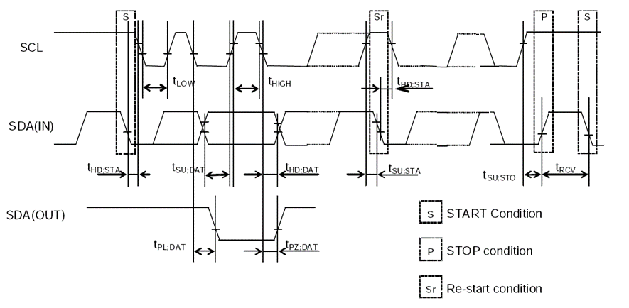

1. I2C bus Timing Chart

Note：When the master device gets access to this slave device through I2C, the whole operation duration should be less than 1s, otherwise it will be reset by the I2C bus through the internal bus overtime function.

Register

## Register list

Address 0x00~0x0F: Basic Time and Calendar Registers

Address 0x10~0x1F: Extended Register Group 1

Address 0x20~30: Extended Register Group 2

Note: 0x10~16 and 0x00~06 with the same function, 0x1B~1F and 0x0B~0F with the same function

1. Basic Time and Calendar Registers

| Address | Function | bit7 | bit6 | bit5 | bit4 | bit3 | bit2 | bit1 | bit0 | R/W |
| --- | --- | --- | --- | --- | --- | --- | --- | --- | --- | --- |
| 0x00 | SEC | ○ | BCD code, Second tens place, 0-5 | | | BCD code, Second ones place, 0-9 | | | | R/W |
| 0x01 | MIN | ○ | BCD code, Minute tens place, 0-5 | | | BCD code, Minute ones place, 0-9 | | | | R/W |
| 0x02 | HOUR | ○ | ○ | BCD code, Hour tens place, 0-2 | | BCD code, Hour ones place, 0-9 | | | | R/W |
| 0x03 | WEEK | ○ | 6 | 5 | 4 | 3 | 2 | 1 | 0 | R/W |
| 0x04 | DAY | ○ | ○ | BCD code, Day tens place, 0-3 | | BCD code, Day ones place, 0-9 | | | | R/W |
| 0x05 | MONTH | ○ | ○ | ○ | BCD code, Month tens place, 0-1 | BCD code, Month ones place, 0-9 | | | | R/W |
| 0x06 | YEAR | BCD code, Year tens place, 0-9 | | | | BCD code, Year ones place, 0-9 | | | | R/W |
| 0x07 | RAM | ● | ● | ● | ● | ● | ● | ● | ● | R/W |
| 0x08 | RSV | Reserved | | | | | | | | R |
| 0x09 | RSV | Reserved | | | | | | | | R |
| 0x0A | RSV | Reserved | | | | | | | | R |
| 0x0B | RSV | Reserved | | | | | | | | R |
| 0x0C | RSV | Reserved | | | | | | | | R |
| 0x0D | Extension Register | TEST | Reserved | | | ● | ● | Reserved | | R/W |
| 0x0E | Flag Register | ○ | ○ | Reserved | | | ○ | VLF | Reserved | R/W |
| 0x0F | Control Register | Reserved | | | | | ○ | ○ | RESET | R/W |

1. Extended Register Group 1

| Address | Function | bit7 | bit6 | bit5 | bit4 | bit3 | bit2 | bit1 | bit0 | R/W |
| --- | --- | --- | --- | --- | --- | --- | --- | --- | --- | --- |
| 0x10 | SEC | ○ | BCD code, Second tens place, 0-5 | | | BCD code, Second ones place, 0-9 | | | | R/W |
| 0x11 | MIN | ○ | BCD code, Minute tens place, 0-5 | | | BCD code, Minute ones place, 0-9 | | | | R/W |
| 0x12 | HOUR | ○ | ○ | BCD code, Hour tens place, 0-2 | | BCD code, Hour ones place, 0-9 | | | | R/W |
| 0x13 | WEEK | ○ | 6 | 5 | 4 | 3 | 2 | 1 | 0 | R/W |
| 0x14 | DAY | ○ | ○ | BCD code, Day tens place, 0-3 | | BCD code, Day ones place, 0-9 | | | | R/W |
| 0x15 | MONTH | ○ | ○ | ○ | BCD code, Month tens place, 0-1 | BCD code, Month ones place, 0-9 | | | | R/W |
| 0x16 | YEAR | BCD code, Year tens place, 0-9 | | | | BCD code, Year ones place, 0-9 | | | | R/W |
| 0x17 | TEMP | 128 | 64 | 32 | 16 | 8 | 4 | 2 | 1 | R |
| 0x18 | RSV | ○ | ○ | ○ | ○ | Reserved | ● | ● | ● | R/W |
| 0x19 | Not use | ○ | ○ | ○ | ○ | ○ | ○ | ○ | ○ | R |
| 0x1A | Not use | ○ | ○ | ○ | ○ | ○ | ○ | ○ | ○ | R |
| 0x1B | RSV | Reserved | | | | | | | | R/W |
| 0x1C | RSV | Reserved | | | | | | | | R/W |
| 0x1D | Extension Register | TEST | Reserved | | | ● | ● | Reserved | | R/W |
| 0x1E | Flag Register | ○ | ○ | Reserved | | | ○ | VLF | Reserved | R/W |
| 0x1F | Control Register | Reserved | | | | | ○ | ○ | RESET | R/W |

1. Extended Register Group2

| Address | Function | bit7 | bit6 | bit5 | bit4 | bit3 | bit2 | bit1 | bit0 | R/W |
| --- | --- | --- | --- | --- | --- | --- | --- | --- | --- | --- |
| 0x20 | Device ID | Vendor ID[3:0] | | | | Ver[3:0] | | | | R |
| 0x21 | Control Register 1 | Reserved: Ensure to be 0x8 | | | | ○ | ○ | ○ | ● | R/W |
| 0x22-26 | RSV | Reserved: Ensure to be 0x00 | | | | | | | | R |
| 0x27 | SubSEC | Reserved | | | | SubSEC[3:0] | | | | R |
| 0x28-30 | RSV | Reserved: Ensure to be 0x00 | | | | | | | | R/W |

Note:

1, After power-up reset or in case VLF bit returns “1”, make sure to initialize all registers to default state before using the RTC. Ensure all inputs are in the required range and the defined values are set for the reserved bits in case the clock cannot work normally.

* During the initial power-up, below bits will be in the state as below:

Initial 0:TEST, RESET.

Initial 1: VLF

* All other register values are undefined, so make sure to reset the module before using it.
* The bits marked with “○” can be read out “0” only after initializing.
* The bits marked with “●” are RAM bits which can be used to write or read any data.
* Only 0 can be written to VLF bits.
* Make sure “0” to be written for TEST bits which are used for testing only.
* Reserved bits must be set to the defined values accordingly.

## Details of Registers

Clock counter registers

| Address | Function | bit7 | bit6 | bit5 | bit4 | bit3 | bit2 | bit1 | bit0 | Default |
| --- | --- | --- | --- | --- | --- | --- | --- | --- | --- | --- |
| 0x00/10 | SEC | ○ | BCD code, Second tens place, 0-5 | | | BCD code, Second ones place, 0-9 | | | | 0x00 |
| 0x01/11 | MIN | ○ | BCD code, Minute tens place, 0-5 | | | BCD code, Minute ones place, 0-9 | | | | 0x00 |
| 0x02/12 | HOUR | ○ | ○ | BCD code, Hour tens place, 0-2 | | BCD code, Hour ones place, 0-9 | | | | 0x00 |

SEC: BCD format, Value: 0~59

MIN: BCD format, Value: 0~59

HOUR: BCD format, Value: 0~23

| Address | Function | bit7 | bit6 | bit5 | bit4 | bit3 | bit2 | bit1 | bit0 | Default |
| --- | --- | --- | --- | --- | --- | --- | --- | --- | --- | --- |
| 0x03/13 | WEEK | ○ | 6 | 5 | 4 | 3 | 2 | 1 | 0 | 0x40 |

WEEK: Value 01h, 02h, 04h, 08h, 10h, 20h, 40h. Only one bit can be set to 1 each time, all others must be set to 0.

1. WEEK Register

| WEEK | Data | bit7 | bit6 | bit5 | bit4 | bit3 | bit2 | bit1 | bit0 |
| --- | --- | --- | --- | --- | --- | --- | --- | --- | --- |
| Sunday | 01h | 0 | 0 | 0 | 0 | 0 | 0 | 0 | 1 |
| Monday | 02h | 0 | 0 | 0 | 0 | 0 | 0 | 1 | 0 |
| Tuesday | 04h | 0 | 0 | 0 | 0 | 0 | 1 | 0 | 0 |
| Wednesday | 08h | 0 | 0 | 0 | 0 | 1 | 0 | 0 | 0 |
| Thursday | 10h | 0 | 0 | 0 | 1 | 0 | 0 | 0 | 0 |
| Friday | 20h | 0 | 0 | 1 | 0 | 0 | 0 | 0 | 0 |
| Saturday | 40h | 0 | 1 | 0 | 0 | 0 | 0 | 0 | 0 |

| Address | Function | bit7 | bit6 | bit5 | bit4 | bit3 | bit2 | bit1 | bit0 | Default |
| --- | --- | --- | --- | --- | --- | --- | --- | --- | --- | --- |
| 0x04/14 | DAY | ○ | ○ | BCD code, Day tens place, 0-3 | | BCD code, Day ones place, 0-9 | | | | 0x01 |

DAY: BCD format, the value range will be adjusted automatically according to the month setting and if a leap year or not .

1. DAY Register Value

| Month | Day Value Range |
| --- | --- |
| 1, 3, 5, 7, 8, 10, 12 | 1~31 |
| 4, 6, 9, 11 | 1~30 |
| February in normal year | 1~28 |
| February in leap year | 1~29 |

| Address | Function | bit7 | bit6 | bit5 | bit4 | bit3 | bit2 | bit1 | bit0 | Default |
| --- | --- | --- | --- | --- | --- | --- | --- | --- | --- | --- |
| 0x05/15 | MONTH | ○ | ○ | ○ | BCD code, Month tens place, 0-1 | BCD code, Month ones place, 0-9 | | | | 0x01 |
| 0x06/16 | YEAR | BCD code, Year tens place, 0-9 | | | | BCD code, Year ones place, 0-9 | | | | 0x00 |

MONTH: BCD format, Value1~12

YEAR: BCD format, Value0~99(2000~2099)

Example: 2020/01/01 Wednesday 21:18:36

| Address | Function | bit7 | bit6 | bit5 | bit4 | bit3 | bit2 | bit1 | bit0 |
| --- | --- | --- | --- | --- | --- | --- | --- | --- | --- |
| 0x00/10 | SEC | ○ | 0 | 1 | 1 | 0 | 1 | 1 | 0 |
| 0x01/11 | MIN | ○ | 0 | 0 | 1 | 1 | 0 | 0 | 0 |
| 0x02/12 | HOUR | ○ | ○ | 1 | 0 | 0 | 0 | 0 | 1 |
| 0x03/13 | WEEK | ○ | 0 | 0 | 0 | 1 | 0 | 0 | 0 |
| 0x04/14 | DAY | ○ | ○ | 0 | 0 | 0 | 0 | 0 | 1 |
| 0x05/15 | MONTH | ○ | ○ | ○ | 0 | 0 | 0 | 0 | 1 |
| 0x06/16 | YEAR | 0 | 0 | 1 | 0 | 0 | 0 | 0 | 0 |

Extension registers

| Address | Function | bit7 | bit6 | bit5 | bit4 | bit3 | bit2 | bit1 | bit0 | Default |
| --- | --- | --- | --- | --- | --- | --- | --- | --- | --- | --- |
| 0x0D/1D | Extension Register | TEST | Reserved | | | ● | ● | Reserved | | 0x02 |

TEST: Test bit, must be set to “0”

Flag registers

| Address | Function | bit7 | bit6 | bit5 | bit4 | bit3 | bit2 | bit1 | bit0 | Default |
| --- | --- | --- | --- | --- | --- | --- | --- | --- | --- | --- |
| 0x0E/1E | Flag Register | ○ | ○ | Reserved | | | ○ | VLF | Reserved | 0x03 |

VLF: Voltage Low Flag bit. When supply voltage is lower than 1.6V, it will be set to “1” and keeps “1” until a “0” is written to it.

Control registers

| Address | Function | bit7 | bit6 | bit5 | bit4 | bit3 | bit2 | bit1 | bit0 | Default |
| --- | --- | --- | --- | --- | --- | --- | --- | --- | --- | --- |
| 0x0F/1F | Control Register | Reserved | | | | | ○ | ○ | RESET | 0x40 |

RESET: Reset IC, prepared for the synchronized starting of time.

Temperature register

| Address | Function | bit7 | bit6 | bit5 | bit4 | bit3 | bit2 | bit1 | bit0 | Default |
| --- | --- | --- | --- | --- | --- | --- | --- | --- | --- | --- |
| 0x17 | TEMP | 128 | 64 | 32 | 16 | 8 | 4 | 2 | 1 | 0x00 |

Read digital temperature data, Temp [℃] = (TEMP[7:0] * 2 -187.19) / 3.218.

RSV register

| Address | Function | bit7 | bit6 | bit5 | bit4 | bit3 | bit2 | bit1 | bit0 | Default |
| --- | --- | --- | --- | --- | --- | --- | --- | --- | --- | --- |
| 0x18 | Reserved | ○ | ○ | ○ | ○ | Reserved | ● | ● | ● | 0x00 |

Bit3 is the reserved bit, suggest being clear to ‘0’.

Device ID register

| Address | Function | bit7 | bit6 | bit5 | bit4 | bit3 | bit2 | bit1 | bit0 | Default |
| --- | --- | --- | --- | --- | --- | --- | --- | --- | --- | --- |
| 0x20 | Device ID | VendorID[3:0] | | | | Ver[3:0] | | | | 0xd2 |

VendorID[3:0]: The fixed value is defined as VendorID[3:0]=1101b=Dh to represent DAPU.

Ver[3:0]: version of the IC

Control Register 1

| Address | Function | bit7 | bit6 | bit5 | bit4 | bit3 | bit2 | bit1 | bit0 | Default |
| --- | --- | --- | --- | --- | --- | --- | --- | --- | --- | --- |
| 0x21 | Control Register 1 | Reserved: must be 0x8 | | | | ○ | ○ | ○ | ● | 0x80 |

Sub-second timer register

| Address | Function | bit7 | bit6 | bit5 | bit4 | bit3 | bit2 | bit1 | bit0 | Default |
| --- | --- | --- | --- | --- | --- | --- | --- | --- | --- | --- |
| 0x27 | SubSEC | Reserved | | | | SubSEC[3:0] | | | | 0x00 |

SubSEC[3:0]: sub second bit, and unit is 1/16s.

I2C Bus Interface

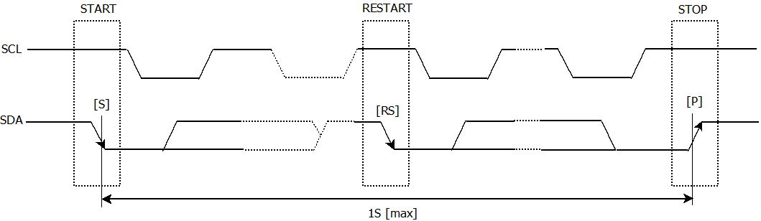

I2C bus supports bi-directional communications through a serial clock line SCL and a serial data line SDA. I2C bus device can be defined as “Master” and “Slave”. INS5710C can only be used as Slave.

## Cautions

I2C bus includes START, RESTART, STOP conditions, the duration between START and STOP must be less than 1 second just in case the bus to be set to standby mode automatically. If the time is more than 1S, INS5710C will reset I2C Interface.

INS5710C I2C bus interface supports single byte read/write operations as well as multiple bytes incremental access. After 0xFF address, the next one will be 0x00.

## Slave Address

1. I2C Bus Slave Address

| Transfer data | Slave address | | | | | | | R/W |
| --- | --- | --- | --- | --- | --- | --- | --- | --- |
| bit7 | bit6 | bit5 | bit4 | bit3 | bit2 | bit1 | bit0 |
| 65h (Read) | 0 | 1 | 1 | 0 | 0 | 1 | 0 | 1 (Read) |
| 64h (Write) | 0 (Write) |

INS5710C I2C bus Slave Address is [0110 010*].

## I2C bus protocol

It is assumed CPU is master and INS5710C is slave in this section.

Write process

I2C bus includes an address auto-increment function, once the initial address has been specified, the INS5710A increments (+1) the address automatically after each data is sent, then to write next data.

CPU sends start condition[S]

CPU sends INS5710C’s slave address with R/W bit to set to write mode

CPU verifies ACK signal from INS5710C

CPU sends write address to INS5710C

CPU verifies ACK signal from INS5710C

CPU sends write data to the address specified at step (4)

CPU verifies ACK signal from INS5710C

Repeat (6) (7) if multiple bytes need to be written, address will be incremented automatically

CPU ends stop condition[P]

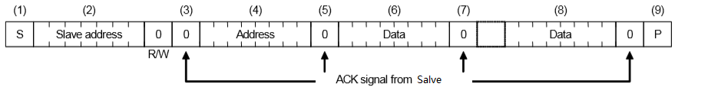

Read process

Writing the address to be read with write mode firstly, then reading the data with read mode.

1. CPU sends start condition[S]

CPU sends INS5710C’s slave address with R/W bit to set to write mode

CPU verifies ACK signal from INS5710C

CPU sends address for reading from INS5710C

CPU verifies ACK signal from INS5710C

CPU sends RESTART condition [Sr]

CPU sends INS5710C’s slave address with R/W bit to set to read mode

CPU verifies ACK signal from INS5710C

CPU reads data from the specified address in step (4)

1. CPU verifies ACK signal from INS5710C
2. Repeat (9) (10) if multiple bytes need to be read, address will be incremented automatically
3. CPU sends ACK signal for “1”
4. CPU sends stop condition[P]

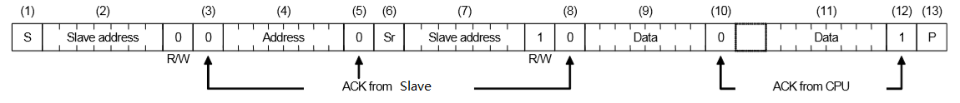

Reflow Soldering Curve

Standard: IPC/JEDEC J-STD-020

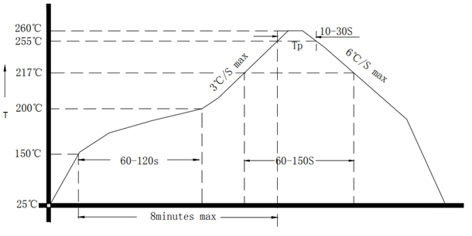

1. Reflow Soldering Curve

Note: It is suggested to solder IC under the condition shown in the curve above. Must pay attention to the temperature and time when manual soldering, if the temperature over +260℃, or you will make the xo performance bad, even damage it.

Dimensions

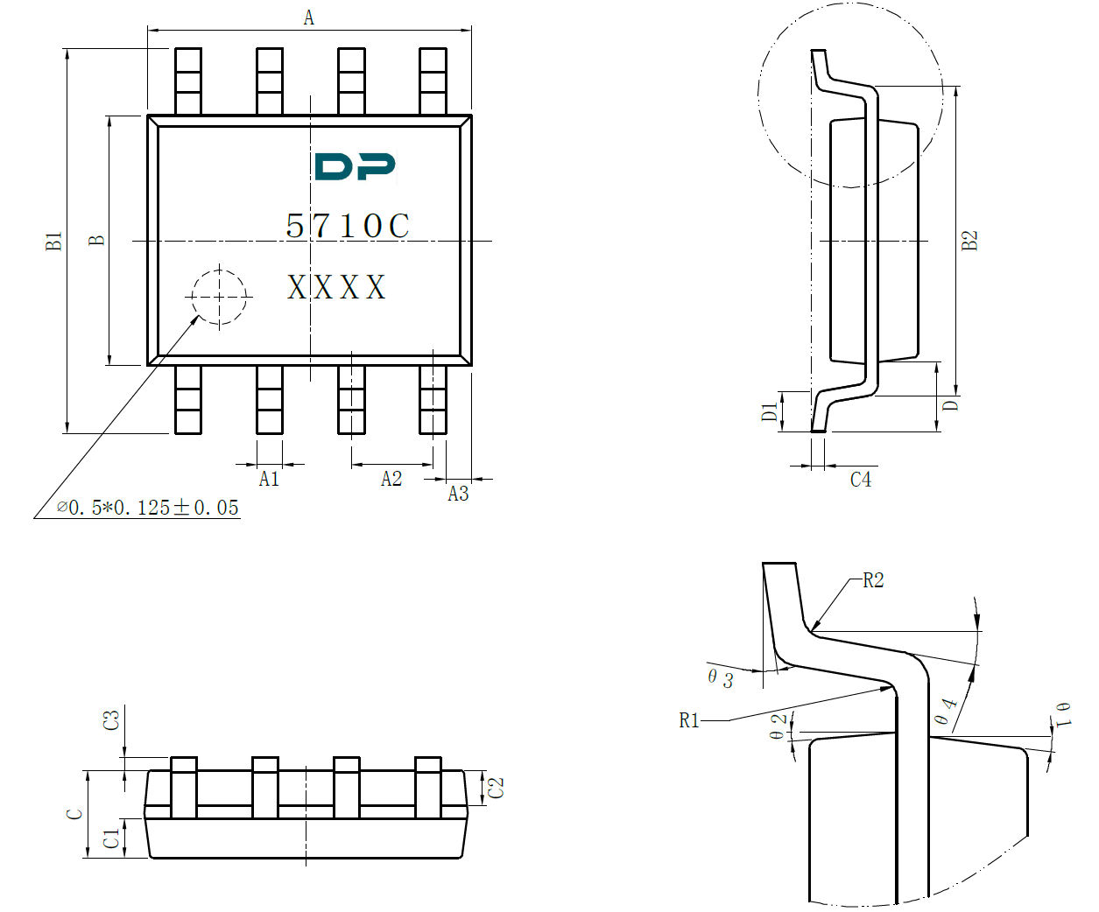

1. Dimension

|  |  |  |  |
| --- | --- | --- | --- |
| **Dimension** | **Min.** | **Typ.** | **Max.** |
| **A** | 4.8 | 4.9 | 5.0 |
| **A1** | 0.356 | -- | 0.456 |
| **A2** | **--** | 1.27 | **--** |
| **A3** | **--** | 0.345 | **--** |
| **B** | 3.8 | 3.9 | 4.0 |
| **B1** | 5.8 | 6.0 | 6.2 |
| **B2** | **--** | 5.00 | **--** |
| **C** | 1.3 | **--** | 1.6 |
| **C1** | 0.55 | -- | 0.65 |
| **C2** | 0.55 | -- | 0.65 |
|  |  | (Unit: mm) | |

|  |  |  |  |
| --- | --- | --- | --- |
| **Dimension** | **Min.** | **Typ.** | **Max.** |
| **C3** | 0.05 | -- | 0.20 |
| **C4** | 0.203 | -- | 0.233 |
| **D** | -- | 1.05 | -- |
| **D1** | 0.4 | -- | 0.8 |
| **R1** | **--** | 0.2 | **--** |
| **R2** | **--** | 0.2 | **--** |
| **θ1** | 17° | | |
| **θ2** | 13° | | |
| **θ3** | 0°~8° | | |
| **θ4** | 4°~12° | | |
|  |  | (Unit: mm) | |

Package Information

1. Package information